*Jupiter Experiment A08*

|  |  |  |
| --- | --- | --- |
|  |  |  |
| Name |  | Lab Section |

*Objective*

* Compare storms on Jupiter to those on Earth.
* View Jupiter’s Moons as Galileo saw them 400 years ago.
* Determine Jupiter’s mass by observing its moons.

*Materials*

Jupiter Observation Printout Jupiter Observation Transparency

Calculator Internet Access

*Procedure*

|  |
| --- |
| ***Part A: Comparison of Storms on Jupiter and Earth*** |

The iconic Great Red Spot of Jupiter may disappear in the next 20 years, according to a researcher at NASA's Jet Propulsion Laboratory (JPL) in California. The massive storm (larger than Earth itself) was first spotted in 1830, and observations from the 1600s also revealed a giant spot on Jupiter's surface that may have been the same storm system. This suggests Jupiter's Great Red Spot (GRS) has been raging for centuries.

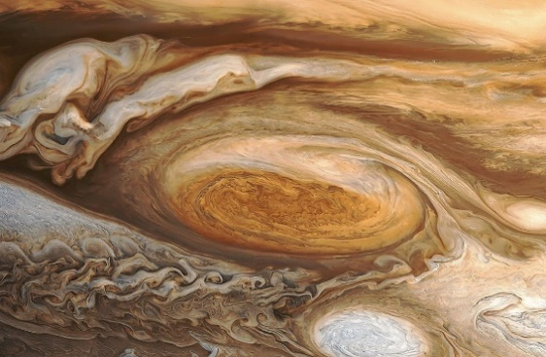

In a recent story, Business Insider spoke with Glenn Orton, a lead Juno mission team member and planetary scientist at JPL, about the giant storm's fate. According to Orton, the storm's vortex has maintained strength because of Jupiter's 300-400 mph (483-640 km/h) jet streams, but like any storm, it won't go on forever. “In truth, the GRS has been shrinking for a long time," Orton told Business Insider.

“The GRS will, in a decade or two become the GRC (Great Red Circle)," Orton said. "Maybe some time after that the GRM," by which he means the Great Red Memory.

In the late 1800s, the storm was perhaps as wide as 30 degrees longitude, Orton said. That works out to more than 35,000 miles (four times the diameter of Earth). When the nuclear-powered spacecraft Voyager 2 flew by Jupiter in 1979, however, the storm had shrunk to a bit more than twice the width of our own planet.

Data on Jupiter's crimson-colored spot reveals that this shrinking is still occurring. As of April 3, 2017, the GRS spanned the width of 10,159 miles (16,350 km), less than 1.3 times Earth's diameter. The longest storm on Earth lasted 31 days, but Jupiter can sustain longer storms because the gas planet has tens of thousands of miles of atmosphere and spins much faster than Earth.

The figure below shows an image of Jupiter, the Great Red Spot, and Earth for size comparison. Below that is a close up of the GRS with the Earth to scale.



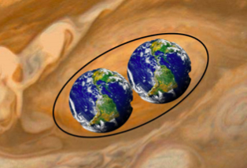

Use the image and ellipse to estimate the semi-major and semi-minor axes of the Great Red Spot by using Earth as a reference scale; DEarth = 12,742 km.

Semi-major axis *a*:

Semi-minor axis *b*:

Circumference *C*:

Provided *a < 3b*, the circumference *C* of an ellipse can be estimated to ~5% accuracy via

Study the images on the following pages that were taken by the Voyager I spacecraft from January 6 to February 3, 1979. These images were taken every Jupiter day, as the spacecraft was approaching the planet from 58 million to 31 million km away during that time frame. By taking the images at the same Jupiter local time, the Great Red Spot appears to remain stationary, while the belts and zones move across the image (in both directions). Notice the action around the Great Red Spot as well as the belts and zones.

Follow the white feature (marked by an X) around one complete rotation on the outer edge of the Great Red Spot, as show in the following images. You will need to then calculate the period of rotation and also the speed of the material at this distance from the center of the Great Red Spot.

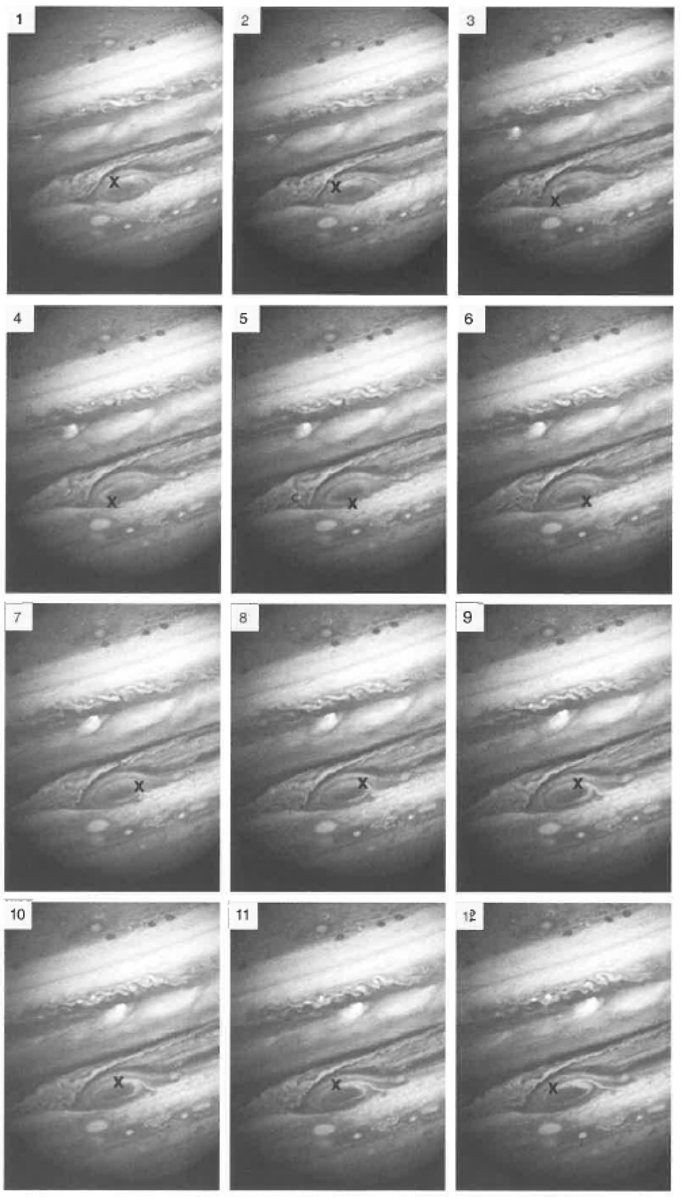

1. The first of 12 images from Voyager I took over 28 days from January 6 to February 3, 1979. Approximately how many hours, on average, passed between each images being taken?

|  |
| --- |
| Enter Answer Here |

1. How many hours are covered by the full set of 12 images, all taken in sequence?

|  |
| --- |
| Enter Answer Here |

1. Divide the circumference of the ellipse you calculated above in kilometers by the number of total hours covered by the 12 images to find the speed of the Great Red Spot at the distance of the white sport from its center.

|  |
| --- |
| Enter Answer Here |

1. Your previous calculate is the approximate *speed* in 1979. What is the rotation *period* at this distance from the center of the Great Red Spot?

|  |
| --- |
| Enter Answer Here |

|  |
| --- |
| ***Part B: Comparison to One of the Strongest Cyclones on Earth*** |

Since a couple of Earths fit into the Great Red Spot, it is meaningless to compare sizes for the Great Red Spot and a cyclone on Earth. However, we can compare speeds and duration.

The cyclone shown here developed from a tropical depression on April 22, 1991 in the Bay of Bengal. Just before it reached landfall, it had windspeeds of 160 mph (258 km/h), the equivalent of a category 5 hurricane. After making landfall near Chittagong, Bangladesh, the storm weakened and dissipated by April 30, a total lifetime of just over a week.

1. Quantitatively compare the maximum speed of the cyclone to your value for the Great Red Spot. How many times faster are the wind speeds on Jupiter? Comment on the comparison.

|  |
| --- |
| Enter Answer Here |

1. Current measurements of the velocity of the outer parts of the Great Red Spot are 610 km/h [D.S. Choi et al., *Icarus*, 188:35-46 (2007)] or the range of 430-680 km/h. Quantitatively compare your results to the range of values and comment.

|  |
| --- |
| Enter Answer Here |

1. What do you think are possible sources of error in your measurements?

|  |
| --- |
| Enter Answer Here |

|  |
| --- |
| ***Part C: Galilean Moons*** |

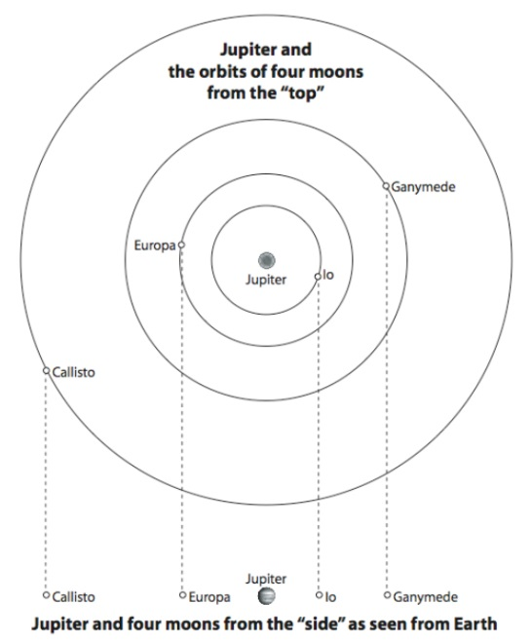In 1610, Galileo used his new spyglass (telescope) to observe Jupiter, and found that it had four orbiting moons. (We now know that it has over 60 moons.) These were the first moons found around another world, and the first bodies indisputably orbiting something besides the Earth.

Like most planets and moons, the four largest moons of Jupiter have orbits that are fairly circular. (Not perfectly circular, but close.) They all orbit in the same direction, counter-clockwise as seen from looking ‘down’ from above Jupiter’s north pole.

From Earth, we never see the moons of Jupiter follow paths that look like circles because from Earth we see the orbits ‘edge-on’, or from the ‘side’. This causes our view of the orbits to look like straight lines and the moons just orbit back and forth along these lines when, in fact, they orbit behind and in front of the planet.

In this activity, we will perform a simplified version of Galileo’s pioneering observations of Jupiter’s moons. You are given a page which shows the observed positions of the Galilean moons over the course of 9 nights. Each of the Galilean moons are represented with their own color.

1. Overlay the transparency on top of the observations sheet. Pick one of the moons, and night-by-night re-draw that moon’s position on the transparency using a dry-erase marker.
2. Once all 9 nights have been drawn for that moon, connect the dots you just drew to see the back-and-forth pattern the moon makes over time.
3. Change colored markers and repeat steps 1-2 for the three remaining moons.
4. For each moon, estimate the orbital period. Remember, the orbital period is the time it takes to complete a full orbit (a complete back and forth in the observations).

**Orbital Period (In Days)**

|  |  |
| --- | --- |
| Red = | Blue = |
| Yellow = | White = |

1. Using the image on the previous page, figure out which colored dot is which moon.

**Name the Moons**

|  |  |
| --- | --- |
| Red = | Blue = |
| Yellow = | White = |

1. Following the blue dot, it reaches to around the +1 and the -1 on the observing sheet. Using the scale factor that the distance from Jupiter to a +1 (or -1) is actually 665,000 miles in space, how far away is this moon from Jupiter on night 1?

|  |
| --- |
| Enter Answer Here |

1. How many miles away is that same moon from Jupiter on night 3?

|  |
| --- |
| Enter Answer Here |

|  |
| --- |
| ***Part D: Mass of Jupiter*** |

**Kepler’s Third Law**­­ - *The square of a planet’s orbital period is proportional to the cube of its semi-major axis.*

Kepler’s 3rd Law tells us that more distant planets orbit the Sun at slower average speeds, obeying a precise mathematical concept.

where *P* is the planet’s orbital period in years, *a* is its semimajor axis (or average distance from the Sun) in astronomical units (AU), and *k* is a constant. Although, *k* is not a universal constant like the speed of light or Newton’s Gravitational Constant *G*. Rather, *k* depends on the particular body that is being orbited.

In a previous lab we used Kepler’s 3rd Law for planets orbiting the Sun. To use this equation in its most simple form we used units of *years* for the orbital period and *Astronomical Units (AU)* for the semimajor axis. However, this law and equation can be applied to other objects in orbit such as moons around a planet. In this case, the semimajor axis is the average distance from the moon to the planet.

To use this law we must use a different form of the above equation. We must apply Isaac Newton’s Law of Gravity to find the version of the equation we need. Doing so gives us

where M1 and M2 are the masses of the two orbiting objects in solar masses and G is Newton’s Gravitational Constant **(6.67 x10-11 m3/kg/s2)**. However, if the mass of one object, such as M1, is much larger than the other, the M1+M2 is nearly equal to M1 and we can ignore M2. This leaves us with

where M is the mass of the object being orbited.

1. Pick one of the moons from Part A of this lab, use the observations of that moon, the scale factor given, and orbital period to calculate the mass of Jupiter using Newton’s version of Kepler’s 3rd Law. You must use the orbital period in seconds (not days) and the semimajor axis in meters (not miles). This will give you a final mass of Jupiter in kilograms (kg). Show all of your work below to receive full credit.

|  |
| --- |
| Enter Answer Here |

1. Knowing the mass of Jupiter is 1.898 x1027 kg, calculate the percent difference of your calculation with the equation below. This gives you an idea of how correct your estimate is compared to the known value:

|  |  |
| --- | --- |
| **Mass of Jupiter** | **Calculated Value** |
| 1.898 x1027 kg |  |

|  |
| --- |
| **Percent Difference** |
|  |

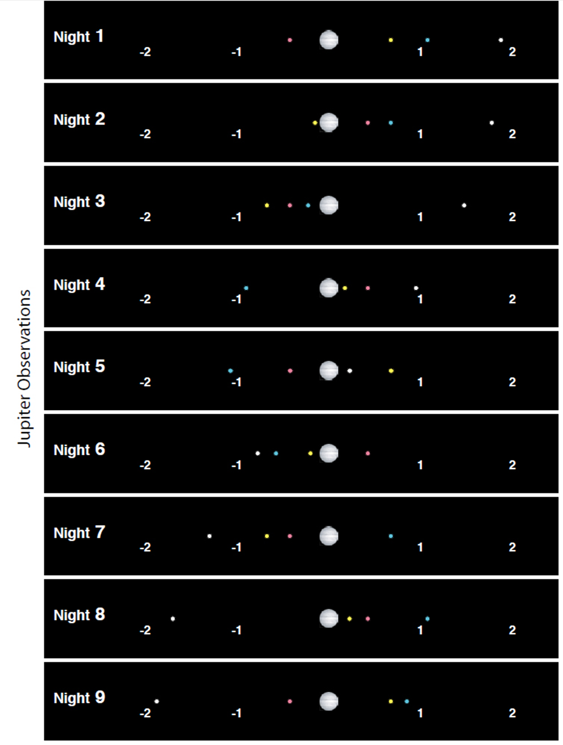

*This lab manual was written by Justin Mason, Old Dominion University, and copied to be made available on this website by Corey Sargent, Old Dominion University, Fall 2021*