*Telescopes & Spectroscopy Experiment A05*

|  |  |  |
| --- | --- | --- |
|  |  |  |
| Name |  | Lab Section |

*Objective*

* Part A: Reflection and Refraction
* Part B: Digital Spectroscopy

*Materials*

Experiment Apparatus:

Light Source Prism

Slit Plate Cardboard Diffraction Grating

Stand Digital Spectrograph w/ Tripod

Viewing Screen Spectrum Tube Carousel w/ Power Supply

*Procedure*

|  |
| --- |
| ***Part A: Reflection and Refraction*** |

**The Law of Reflection**

The shape and location of the image created by reflection from a mirror of any shape is determined by just a few simple principles. One of these principles you already know: light propagates in a straight line. Another principle is called *The Law of Reflection.*

The Law of Reflection can be stated in simple terms: I=R, where the *angle of incidence (I)*—the angle of the incoming rays in respect to the normal (N), is *equal to the angle of reflection (R)*—the angle of the reflected rays in respect to the normal, when the incident rays, normal, and reflected rays lay in the same plane.

**The Law of Refraction**

The direction of light propagation changes abruptly when light encounters a reflective surface. The direction also changes abruptly when light passes across a boundary between two different media, such as between air and acrylic, or between glass and water. In this case, the change of direction is called *Refraction*.

As for reflection, a simple law characterizes the behavior of a refracted ray of light. According to the *Law of Refraction*, also known as *Snell’s Law*:

**(1)**

where the quantities *n1* and *n2* are constants, called *indices of refraction*, that depend on the two media through which the light is passing. The angles *θ1* and *θ2* are the angles that the ray of light makes with the normal to the boundary between the two media. In this experiment you will view this law in action.

***For this lab, you will be working with lasers. Please make sure you point the lasers towards the walls and not towards anyone else in the lab. Be aware of where the lasers are pointed and who is sitting around you.***

***Refraction***

***Rectangular Prism***

1. 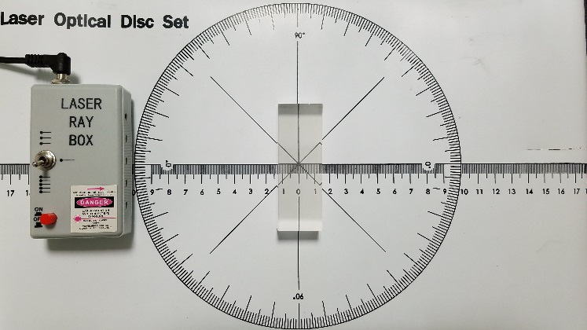In the metal case optics kit, remove the mat with distance and angle measurements. Unroll it and lay it flat on the table. (You may need to place weights on the corners to make it lay flat.)
2. Plug in the *Laser Ray Box*, move the switch to the 5 laser side, and place the box along the 0° line and near the edge of the circle.
3. Lay the rectangular prism in the middle of the mat and align it parallel to the *Laser Ray Box*. Make sure the ‘frosted’ side of the prism is facing down.

1. Turn on the *Laser Ray Box* and observe how the lasers pass through the prism. In the lab report for this experiment, draw a figure of what the laser rays look like as they pass through the prism.
2. Slowly rotate the prism (clockwise or counter-clockwise), and observe what happens to the path of the lasers through the prism.
3. At around 30°, stop rotating and again draw the path of the rays through the prism.

***Rectangular Prism***

Draw the path of the lasers through the rectangular prism:

**Description of the Laser Rays:**

*Are the laser rays bent as they pass into the perpendicular side of the prism?*

Type Answer Here

***Rotated Rectangular Prism***

Draw the path of the lasers through the prism:

**Description of the Laser Rays:**

*Are the laser rays bent as they pass into the perpendicular side of the prism?*

Type Answer Here

***Convex Lens***

1. 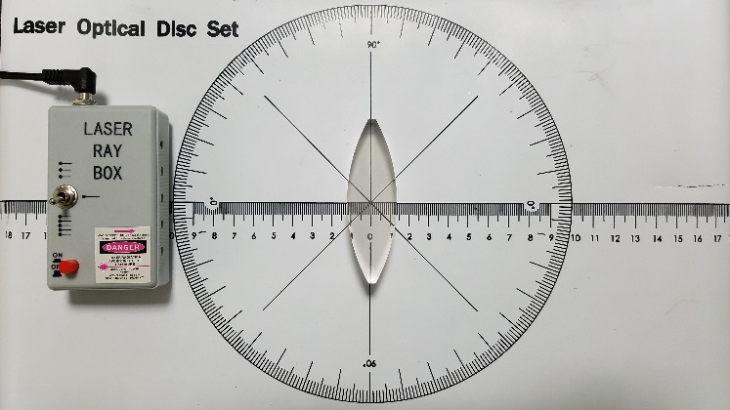Replace the rectangular prism with the double-convex lens. (This is the lens that is curved outwards on both sides.) Place the lens in the middle of the mat so that it is parallel to the laser ray box. Again, make sure the ‘frosted’ side is facing downwards.
2. Turn on the *Laser Ray Box*, and observe how the laser rays pass through the lens. In the lab report, draw the path of the lasers through the lens and explain what you see.
3. Rotate the lens and observe what happens to the lasers as it’s turned.

***Convex Lens***

Draw the path of the lasers through the convex lens:

**Description of the Laser Rays:**

*Are the laser rays bent as they pass into the lens? Do they all focus at the same point or do they all move away from each other?*

Type Answer Here

***Concave Lens***

1. 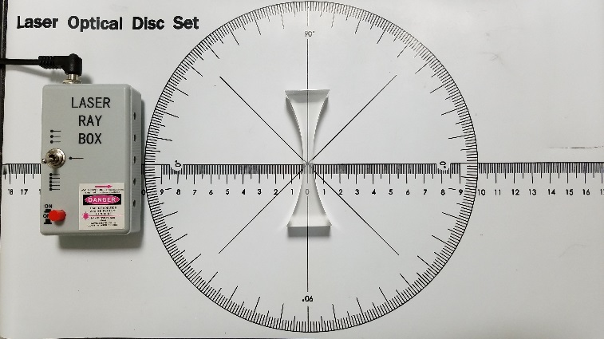Replace the convex lens with the concave lens. (This is the lens that is curved inwards on both sides.) Place the lens in the middle of the mat. Again, make sure the ‘frosted’ side is facing downwards.
2. Turn on the *Laser Ray Box*, and observe how the laser rays pass through the lens. In the lab report, draw the path of the lasers through the lens and explain what you see.
3. Rotate the lens and observe what happens to the lasers as it’s turned.

***Concave Lens***

Draw the path of the lasers through the concave lens:

**Description of the Laser Rays:**

*Are the laser rays bent as they pass into the lens? Do they all focus at the same point or do they all move away from each other?*

Type Answer Here

***Reflection***

***Flat Mirror***

1. 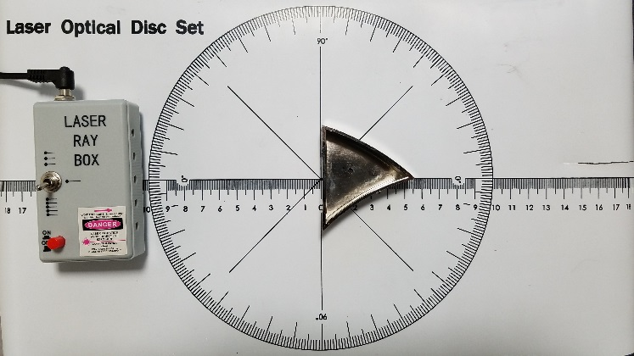Keeping the same setup as part B, replace the triangular lens with the three-sided mirror (labeled as *Ray Optics Mirror*). Place the mirror in the middle of the mat and parallel to the *Laser Ray Box*.
2. Turn the mirror so that the flat side of the mirror is facing the *Laser Ray Box*.
3. Turn on the *Laser Ray Box* and observe the paths of the laser rays as you rotate the mirror. In the lab report, draw the path of the lasers through the lens and explain what you see.

***Flat Mirror***

Draw the path of the lasers off of the flat mirror:

**Description of the Laser Rays:**

*Describe the path of the lasers. Do they pass through the mirror or bounce off? Do they focus at any point? What happens if you rotate the flat mirror side to side?*

Type Answer Here

***Convex Mirror***

1. 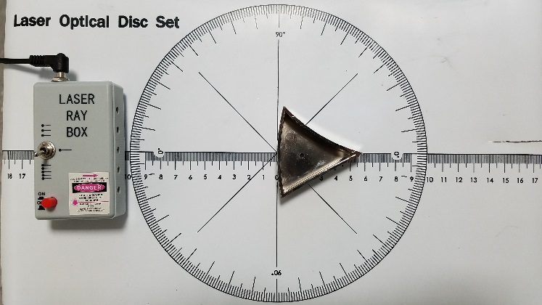Turn the mirror so that the convex side of the mirror is facing the *Laser Ray Box*. (This is the side of the mirror that is curved outwards.) In the lab report, draw the path of the lasers through the lens and explain what you see.

***Convex Mirror***

Draw the path of the lasers off of the convex mirror:

**Description of the Laser Rays:**

*Do the laser rays all focus at the same point or do they all move away from each other?*

Type Answer Here

***Concave Mirror***

1. 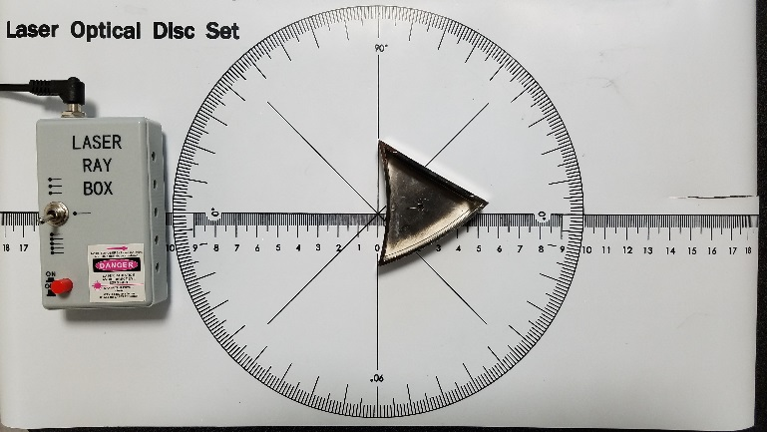Turn the mirror around so that the concave side faces the *Laser Ray Box*. (This is the side that is curved inwards.)
2. Observe the paths of the laser rays. In the lab report, draw the path of the lasers through the lens and explain what you see.

***Concave Mirror***

Draw the path of the lasers off of the concave mirror:

**Description of the Laser Rays:**

*Do the laser rays all focus at the same point or do they all move away from each other?*

Type Answer Here

|  |
| --- |
| ***Part B: Diffraction of Light*** |

## **Properties of Light**

Light can be accurately described in two fundamentally different ways: as an electromagnetic wave, or particles of energy called photons. For the purposes of this experiment we shall focus on the wave-like properties of light.

Visible light is actually a form of electromagnetic radiation. However, it is only a very small segment of the total electromagnetic radiation present. These radiations are grouped according to their respective **wavelengths** and collectively they comprise the **electromagnetic spectrum**. From the figure below, we see that the vast majority of electromagnetic radiation is outside of the visible light range.

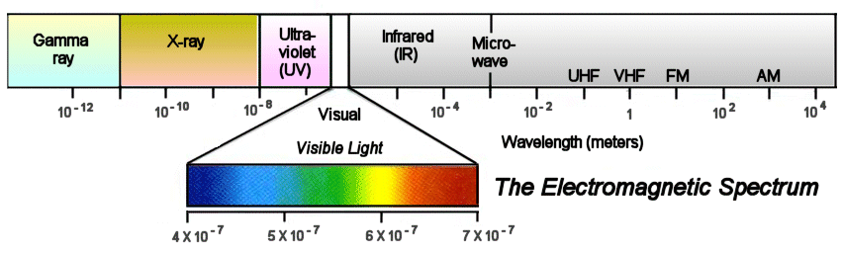

## **Refraction, Prisms, and Diffraction Gratings**

White light is actually composed of all the component colors present in the visible light spectrum. Each of these colors has a different wavelength within the electromagnetic spectrum. From longest to shortest wavelength, (~ 750 to 390 nm), the colors are: *Red, Orange, Yellow, Green, Blue, Indigo, and Violet* **(ROYGBIV).** The oldest method of separating white light into its component colors is by passing white light through a prism. Because of the prism’s physical properties, as light passes through a prism it **refracts**, separating the white light into colors.

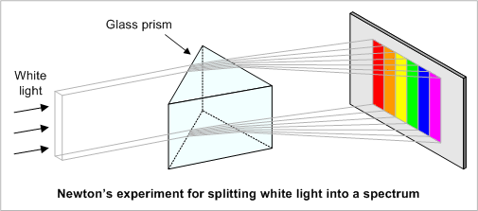

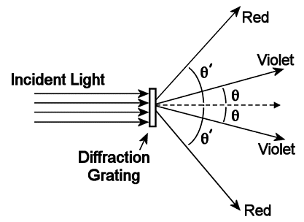Refraction also occurs when white light passes through a **diffraction grating**. A diffraction grating has many closely spaced, parallel grooves (commonly 5000-12000 per cm), and acts as a “super prism”. As white light encounters these barriers, the light bends and separates into component colors as shown in the figure to the right.

1. Set up the light source and prism similar to image below.

(The piece labeled “slit plate” is magnetized and sticks to the front of the light source in order to have smaller rays of light. You could even tape paper over the other slits if you would like just one ray for your source.)

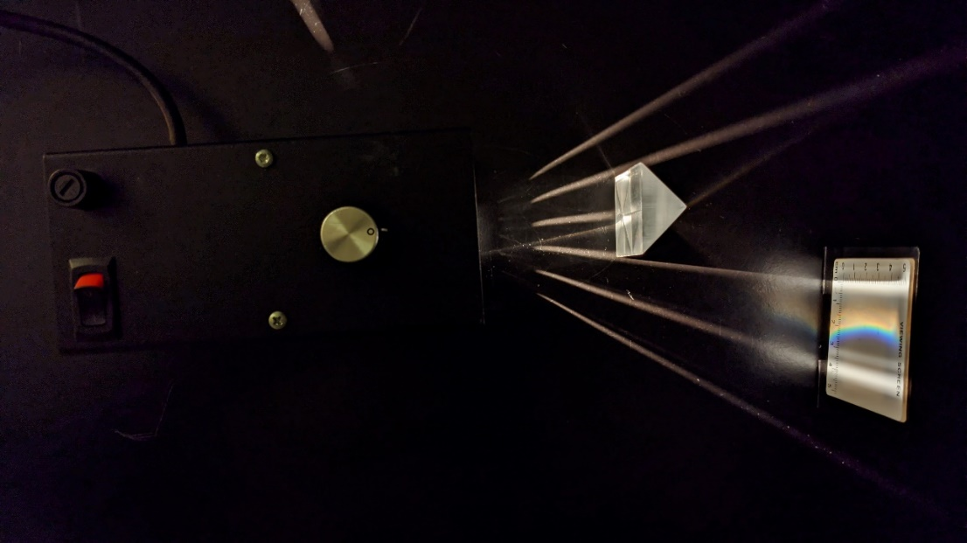

1. Using a camera (cell phones work well), take a photo of your prism and spectra and include it in the report below.

Delete this text box and include your prism/spectra photo here.

1. Take the small, cardboard diffraction grating in one hand, hold it up close to your eye, and look at the light source.
2. Describe what you see. Is it similar to the spectra from the prism?

|  |
| --- |
| Enter Answer Here |

1. What color is closest to the light source? Is the wavelength of that color shorter or longer than what is farthest from the source?

|  |
| --- |
| Enter Answer Here |

1. Are there multiple spectra in other directions?

|  |
| --- |
| Enter Answer Here |

|  |
| --- |
| ***Part C: Spectroscopy*** |

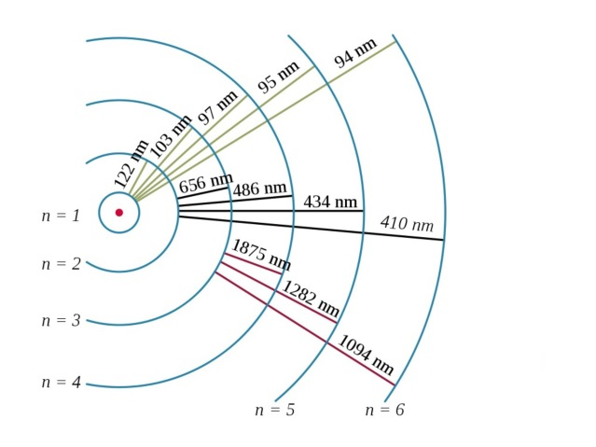The energy stored by electrons in atoms has a strange but important property: The electrons can have only particular amounts of energy and not random energies in between. This is much like using a step ladder, where you can only stand on the rungs of the ladder, but you cannot stand in between the rungs. The energies of the electrons in atoms are like the rungs of the ladder. Only a few particular energies are possible; energies between these special few are not possible. The possible energies are known as energy levels of an atom.

An electron can rise from a low energy level to a higher one by absorbing energy. It can also fall from a high level to a lower one by giving off energy (usually in the form of light). Such changes are called energy level transitions. Because energy must be conserved, energy level transitions can only occur when an electron gains or loses the specific amount of energy separating the two levels.

The figure to the right shows the wavelengths of light that are emitted for various transitions of the hydrogen atom. The different wavelengths correspond to different colors emitted based on how far the electron jumps. Note that the larger the jump the shorter the wavelength of light given off (and thus the higher the energy of the photon).

Of extreme importance is the fact that each element has its own specific set of electron energy levels. Therefore, each element has its own specific set of energy level transitions. Much like fingerprints can be used in a crime lab, the energy level transitions of different elements can be used to determine what materials make up a star, galaxy, or even an exoplanet’s atmosphere.

1. Take the digital spectrograph (it’s just a webcam with a diffraction grating like you used in Part A) and plug it in to a USB port on the computer.
2. Next, open the program *RSpec Explorer*.
3. Once the program is open, be sure it is in *live camera* mode and that you can see the camera’s view on the computer.
4. Point the camera at the light source from Part A and notice its spectra in the program. The program works by plotting brightness vs. wavelength for the camera’s view. (Again, that diffraction grating is important to seeing the spectra and determining wavelength.)
5. What colors are present in the spectra this time? Are they the same as before? What color is closest to the light source?

|  |
| --- |
| Enter Answer Here |

1. Do all the colors have the same brightness? What colors are the brightest for the light source?

|  |
| --- |
| Enter Answer Here |

1. Next, turn on the big green carousel using the switch on the back. Whatever bulb is on the side opposite the switch should light up. It may take up to 30 seconds or so for the bulb to warm up and turn on. Don’t be surprised if it doesn’t turn on immediately.
2. Grab the middle portion of the carousel and turn it so that the element helium (He) is facing forward and lights up. Take note of the color of the glowing gas in the tube.
3. Point the camera at the light source. On the left side of the program is a live view from the camera. Move the lamp to the left inside of this view.

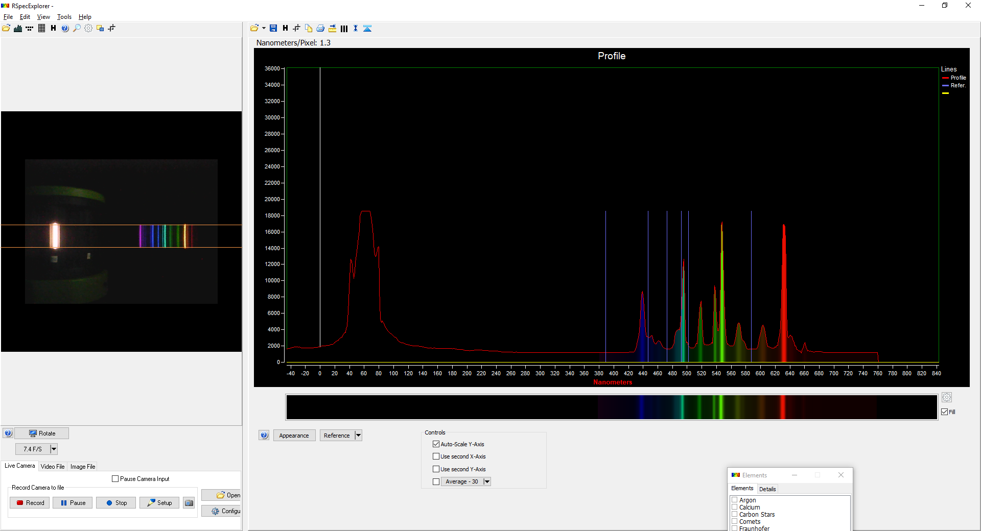

*The horizontal lines in this window can be dragged*

*closer together to limit Interference from other light sources.*

***Calibration Phase***

1. Notice in the program’s intensity vs. wavelength graph there is a peak to the far left. This is the spectrum tube itself glowing. It’s a very intense light, and thus, a very intense peak. Move your camera or carousel to line up that peak with the vertical, yellow line in the graph.
2. At the top of the program, click on the *Elements* button, which is shown as a button with three vertical lines. From this list, click the box next to helium and more vertical lines appear on the graph. These are where the spectral peaks should occur in your graph. *We will need to calibrate the program to line up these peaks.*
3. At the top of the program, click on Tools 🡪 Calibrate.
4. In the new window that appears, right click on any number in the table and choose *Erase Entire Grid*. It will ask if you are sure. Choose *Yes*. Now click in the top left box of the table you just erased.
5. The image below highlights the next part of this process. We want to click on the spectral peak immediately followed by clicking the correct, blue vertical line that matches. Click on the top point of each peak followed by clicking on the matching numbered blue line. (i.e. – Click peak 1 then line 1. Click peak 2 then line 2. And so forth…) As you click through this process, the table on the left will automatically fill with data for you.

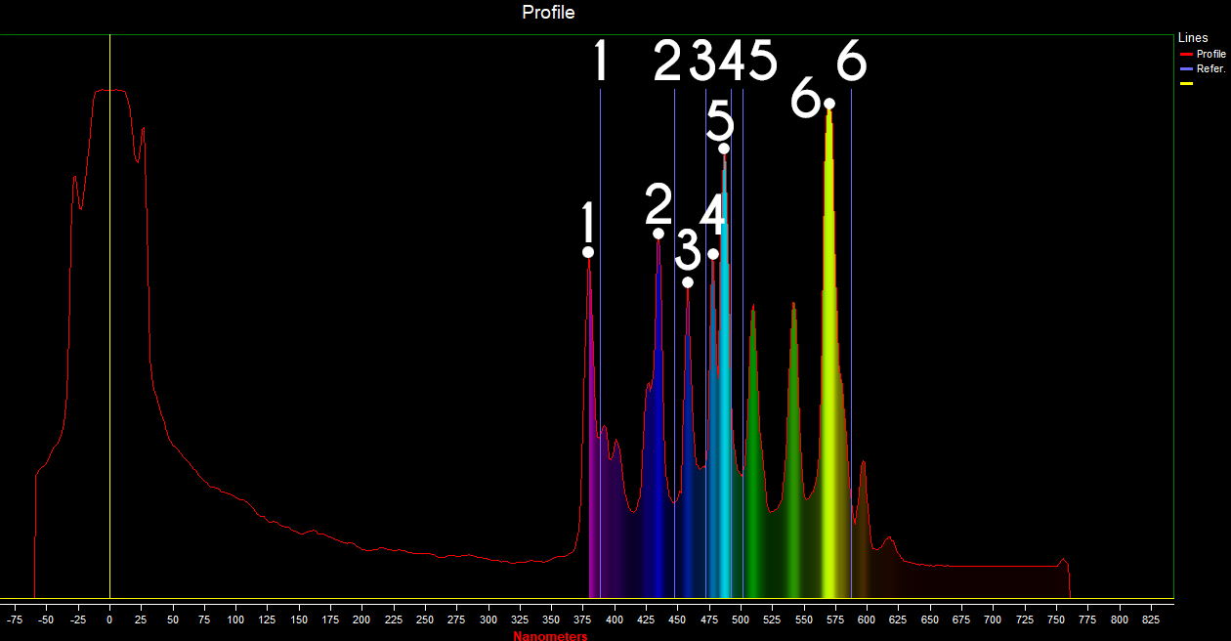

1. After finishing the last spectral peak, click “Apply” and then close the calibration window. The peaks should have now shifted to be aligned with the blue lines. ***At this point, be careful to NOT move either the carousel or the camera or you will have to run the calibration phase again.***

***Data Collection***

1. Now that the calibration phase is done, record the wavelength for the spectral emission peaks that occur for the element helium.

|  |  |  |  |  |  |  |
| --- | --- | --- | --- | --- | --- | --- |
| **Line** | **1** | **2** | **3** | **4** | **5** | **6** |
| **Wavelength (nm)** |  |  |  |  |  |  |

1. Now, turn the carousel to hydrogen (H). Be careful to not bump the camera or move carousel’s position on the table. Just rotate the middle portion of the carousel so that hydrogen is forward facing and lights up.
2. Reopen the *Elements* option (the button with three vertical lines), uncheck the box for helium, and check the one for hydrogen. Record the wavelength for the emission peaks of hydrogen.

|  |  |  |  |  |  |  |  |
| --- | --- | --- | --- | --- | --- | --- | --- |
| **Line** | **1** | **2** | **3** | **4** | **5** | **6** | **7** |
| **Wavelength (nm)** |  |  |  |  |  |  |  |

1. At the top of the program is a button that looks like a triangle with a line resting on it. Click this button to create a *trace* of your spectra for hydrogen.
2. Switch back to the helium tube to visually compare the hydrogen trace to the spectra of helium. Explain, in your own words, the underlying physics of why the trace for the hydrogen spectrum is different for the spectrum for helium.

|  |
| --- |
| Enter Answer Here |

***Unknown Elements***

1. Clear the trace for hydrogen by clicking the drop-down menu labeled *Reference* (this is towards the bottom of the program) and then choosing *Close Reference Series*.
2. View each of the element tubes labeled #1, #2, and #3. Identify the elements in each of these tubes using either the *Elements* option in the program to highlight emission lines, or using the images found here: <http://hyperphysics.phy-astr.gsu.edu/hbase/quantum/atspect3.html#c1>
   1. Element #1 –
   2. Element #2 –
   3. Element #3 –

***Complex Spectra***

1. The spectra you have seen so far are simple as they only contain one element. Not all spectra are quite as simple as this. Turn the carousel to the gas tube labeled *Air*. This is normal air you breathe from our atmosphere. Create a trace of the spectra just as you did earlier for hydrogen.
2. Switch the carousel back to tube labeled #1. Based on your recent findings, discuss why these two tubes are very similar. Be specific and thorough.

|  |
| --- |
| Enter Answer Here |

1. What differences can you find between the two? (Give specific emission wavelengths where these differ.) Why might they be similar but not exact? Cite specific examples of what would make them different.

|  |
| --- |
| Enter Answer Here |

*This lab manual was written by Justin Mason, Old Dominion University, and copied to be made available on this website by Corey Sargent, Old Dominion University, Fall 2021*