*Extrasolar Planets Experiment A10*

|  |  |  |
| --- | --- | --- |
|  |  |  |
| Name |  | Lab Section |

*Objective*

* Part A – Doppler Shift
* Part B – Transit Method
* Part C – 51 Pegasi – Discovery of a New Planet

*Materials*

Computer with Internet Access Calculator

*Theory*

The abundance and characteristics of planets around other stars has long been a topic of great interest in astronomy. It has direct implications on our understanding of our own planet and solar system. It is also directly linked with the broader philosophical question “are we alone in the universe?” If other stars commonly have planets, this would greatly increase the likelihood of us discovering life elsewhere in the universe.

Planets around other stars proved very elusive to find. In 1995, astronomers had infrared observations of protosolar systems and had detected planets around pulsars. However, no planets around regular stars were known despite the considerable effort that had been exerted to find them. All that we knew about planets came from those in our own solar system.

All of that changed beginning in 1995 when an extrasolar planet was discovered using the radial velocity technique. As of 2014 nearly over 1800 extrasolar planets are known, with more being found at an increasing rate. Several large programs are still underway to find more extrasolar planets, including the Kepler space mission. Launched in 2009, Kepler is staring at over 100,000 stars, waiting for a planet to cross in front of one of them.

|  |
| --- |
| ***Part A: Doppler Shift*** |

The center of mass is a very important concept when discussing extrasolar planets. It can be thought of as a “balancing point” between two objects of different mass. It is always found on the line between the two objects and is located closer to the more massive object. Both the star and the extrasolar planet will orbit around the center of mass (sometimes referred to as the barycenter). If the two masses are equal the center of mass must be halfway between the two masses. If they have different masses, the center of mass is always found closer to the more massive object. When one object is considerably more massive than the other, the center of mass may actually be inside the more massive object.

We will return to the *ClassAction* program from previous experiments, which is installed on the lab computers, or you can download it here

<https://astro.unl.edu/nativeapps/>

From the opening page, click on **Extrasolar Planets**, choose **Animations** at the bottom left, and then choose **Influence of Planets on the Sun**

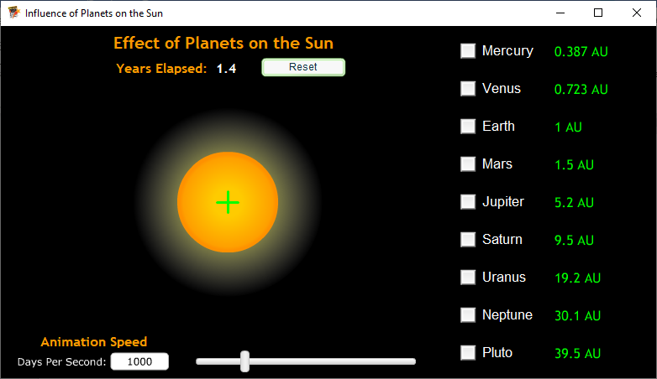

This will open a simulation to see the effect that the planets of our solar system have on the center of mass of the solar system. This simulation shows the movement of the Sun due to the gravitational pull of the planets. The contribution from each planet can be added or subtracted with the check boxes on the side, and the green crosshairs show the center of the solar system.

Using the check boxes, turn on/off several of the planets and see the effect they have on the motion of the Sun.

1. Describe the motion of the Sun once you have turned on several of the terrestrial planets.

|  |
| --- |
| Enter Answer Here |

1. Describe the motion of the Sun once you have turned on several of the Jovian planets.

|  |
| --- |
| Enter Answer Here |

1. Why does the Sun make this pattern and not that of a perfect circle (or ellipse) around the center of the solar system?

|  |
| --- |
| Enter Answer Here |

1. Are there times when the center of the solar system is ever outside of the Sun?

|  |
| --- |
| Enter Answer Here |

This ‘wobble’ effect happens to all stars with planets. As the star orbits the center of mass it gives the star a radial velocity. Radial velocity is the velocity along the line of sight of the star (motion towards or away from the observer). The next simulation shows a star and planet in orbit around each other while tracing out the star’s radial velocity curve.

1. Close the previous simulation and then open **Radial Velocity Graph**.

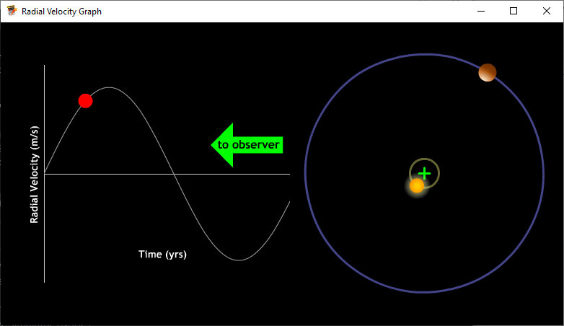

The graph in the middle shows the amplitude of the radial velocity for the star. When the amplitude is highest, the radial velocity is largest. We’ll see how this information can be used in the next simulation.

1. At what position in the star’s orbit is its radial velocity the largest?

|  |
| --- |
| Enter Answer Here |

1. At what position does the star not have any radial velocity?

|  |
| --- |
| Enter Answer Here |

Notice that the planet and the star both orbit the same center of mass. They both move together and not the planet just orbiting a stationary star. This effect can be measured by looking for the Doppler shift of the star’s spectrum. When an object is moving towards or away from you the wavelength of light emitted by that moving object is shifted. This effect is called the *Doppler Shift*. In everyday situations, we don’t normally notice this for light, but it is easy to observe for sound. A common example is that of a police siren that changes to a lower pitch as it passes by you.

1. Close the previous simulation and open **Doppler Shift Demonstrator**

The object labelled *S* is the source of the light while *O* is the observer. In astronomy, the source is a star and the observer is your telescope.

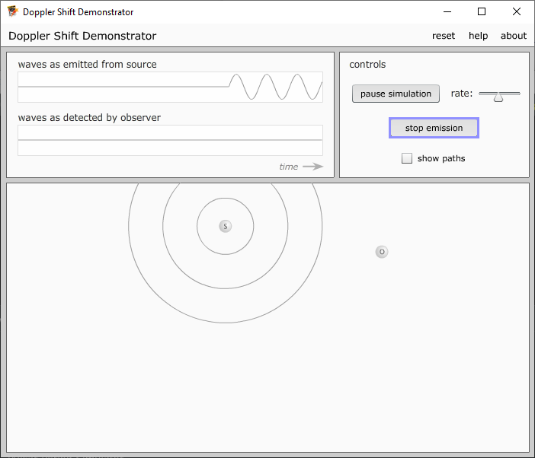

1. Click *start emission* to have the source begin giving off waves of light.
2. The two boxes in the top left are what the source gives off and what the object sees.
3. Click and drag the *object* around and describe what happens to the waves that it sees.

|  |
| --- |
| Enter Answer Here |

1. Click and drag the *source* around this time. Does this have the same effect on what the *object* sees?

|  |
| --- |
| Enter Answer Here |

1. Drag the *object* perpendicular (side-to-side) compared to the *source*. Not back-and-forth. Does the *object* see the wave distorted for this motion? Which motion does distort what the *object* sees? Side-to-side or back-and-forth?

|  |
| --- |
| Enter Answer Here |

1. Open one last simulation called **Extrasolar Planet Radial Velocity Demonstrator**

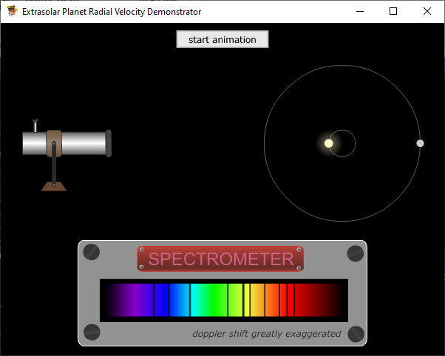

1. Click on *start animation* and observe the observed spectrum of the star as the planet and star orbit each other. The black lines are absorption lines in the spectrum coming from the atmosphere of the star.
2. The absorption lines are red-shifted and blue-shifted depending on the motion of the star. When are the absorption lines red-shifted? What direction is the planet moving at this time?

|  |
| --- |
| Enter Answer Here |

1. When are the absorption lines blue-shifted? What direction is the planet moving at this time?

|  |
| --- |
| Enter Answer Here |

1. Is there a point in the orbit that the absorption spectrum would not be red- or blue-shifted?

|  |
| --- |
| Enter Answer Here |

|  |
| --- |
| ***Part B: Transit Method*** |

If a planet passes directly between a star and an observer's line of sight, it blocks out a tiny portion of the star's light, thus reducing its apparent brightness.

Sensitive instruments can detect this periodic dip in brightness. From the period and depth of the transits, the orbit and size of the planetary companions can be calculated. Smaller planets will produce a smaller effect, and vice-versa. A terrestrial planet in an Earth-like orbit, for example, would produce a minute dip in stellar brightness that would last just a few hours.

Missions that use the transit method, such as the Kepler and CoRoT spacecraft, are able to monitor large numbers of stars at once for the dimming caused by a transit. The Kepler mission has discovered more than 1,000 potential exoplanets using this method.

1. Close the last simulation you used for Part A, and open **Transit Simulator (NAAP)**

The panel in the upper right shows the total amount of light received from the star. The visualization panel in the upper left shows what the star’s disc would look like from earth if we had a sufficiently powerful telescope. The relative sizes of the star and planet are to scale in this simulator. Experiment with the controls until you are comfortable with their functionality.

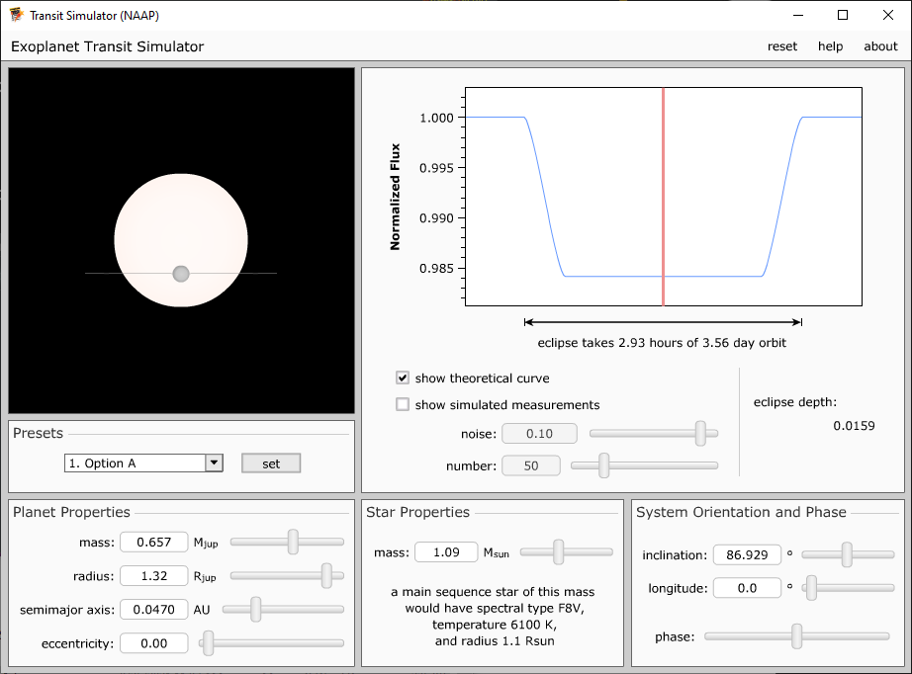

1. Select *Option A* in the Presets section and click set. This option configures the simulator for Jupiter in a circular orbit of 1 AU with an inclination of 90°.
2. Determine how increasing each of the following variables would affect the depth and duration of the eclipse. (Note: the transit duration is shown underneath the flux plot.)
3. Radius of the planet:

|  |
| --- |
| Enter Answer Here |

1. Semimajor axis:

|  |
| --- |
| Enter Answer Here |

1. Mass (and thus, temperature and radius) of the Star:

|  |
| --- |
| Enter Answer Here |

1. Inclination:

|  |
| --- |
| Enter Answer Here |

1. The Kepler Space Probe was launched in 2008 and photometrically detects extrasolar planets during transit. It is predicted to have a photometric accuracy of 1 part in 50,000 (a noise level of 0.00002). It points its telescope at a fixed location in the sky and continuously watches 150,000 stars to see if any of them periodically dim and get fainter.

Select *Option B* in the Presets section and click set. This preset is very similar to the Earth in its orbit. Select *show simulated measurements* and set the noise to 0.00002.

1. Do you think Kepler will be able to detect Earth-sized planets in transit?

|  |
| --- |
| Enter Answer Here |

1. How long does the eclipse of an earth-like planet take?

|  |
| --- |
| Enter Answer Here |

1. How much time passes between eclipses?

|  |
| --- |
| Enter Answer Here |

1. What obstacles would a ground-based mission to detect Earth-like planets face?

|  |
| --- |
| Enter Answer Here |

|  |
| --- |
| ***Part C: 51 Pegasi - Discovery of a New Planet*** |

The figure below the observed radial velocities of the star 51 Pegasi over a period of about 33 days. The data were obtained by measuring the Doppler shift for the star using the Doppler formula. We find out what the shift in the wavelength is compared to the rest wavelength and multiply that by the speed of light.

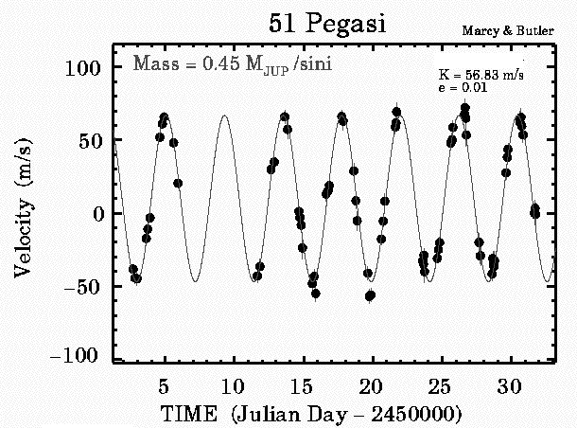

1. A period is defined as one complete cycle; that is, where the radial velocities return to the same position on the curve but at a later time. How many cycles did the star go through during the 33 or so days of observations?

|  |
| --- |
| Enter Answer Here |

1. What is the period, *P*, in days of one complete cycles? (Number of days for these observations divided by number of cycles.)

|  |
| --- |
| Enter Answer Here |

1. What is *P* in years? (Hint: Divide the period in days by the number of days in a year.)

|  |
| --- |
| Enter Answer Here |

1. Why are there data missing? Why are there sizable gaps in the data? (Hint: Some gaps are a little over ½ day long and these are observations from the ground.)

|  |
| --- |
| Enter Answer Here |

1. What is the amplitude, *K*? To find this, take one-half of the value of the full range of the velocities.

|  |
| --- |
| Enter Answer Here |

1. We use a simplified form of Newton’s version of Kepler’s Third Law for determining the mass of the planet. The equation we use is

Period *P* should be expressed as a fraction of a year, and amplitude *K* should be expressed in meters per second (m/s). Twelve years is approximate orbital period for Jupiter, and 13 m/s is the magnitude of the “wobble” of the Sun due to Jupiter’s gravitational pull. The answer we get is the ratio of the mass of the planet (Mplanet) to the mass of Jupiter (MJupiter). Put in your values for *P* and *K* and calculate the mass of this new planet in terms of the mass of Jupiter.

1. We assume that the parent star is 1 solar mass and that the planet is much, much less massive than the star (the same case as with our solar system). Calculate the distance this planet is away from its star, in astronomical units (AU), using Kepler’s Third Law, . Again, *P* is expressed as a fraction of a year, and *a* represents the astronomical units. Solve for *a*.
2. Compare your results with the set of published results shown in the following table. Make your comparisons quantitative by calculating the *percentage differences:*

|  |  |  |  |
| --- | --- | --- | --- |
| **Characteristic** | **Published Value** | **My Value** | **Percent Difference** |
| Mass | 0.45 MJupiter |  |  |
| Period (*P*) | 4.233 days |  |  |
| Amplitude (*K*) | 56.83 m/s |  |  |
| Distance from star (*a*) | 0.0527 ±0.0030 AU |  |  |

1. Where would the new planet fit in if it were in our solar system? The figure below depicts the distances of the planets from the Sun approximately to scale: Mercury, 0.4 AU; Venus, 0.7 AU; Earth, 1.0 AU; Mars, 1.5 AU; Jupiter, 5.2 AU

J

M

E

V

M

1. Science is based on the ability to predict outcomes. However, nothing prepared astronomers for the characteristics of this “new” solar system. Consider the mass of this planets as well as its distance from its star. Why was the discovery such a surprise when compared to our solar system?

|  |
| --- |
| Enter Answer Here |

1. If this actually is a planet, is it possibly hospitable to life? Comment on what the environment would be like on this planet.

|  |
| --- |
| Enter Answer Here |

*This lab manual was written by Justin Mason, Old Dominion University, and copied to be made available on this website by Corey Sargent, Old Dominion University, Fall 2021*