*Planetary Atmospheres Experiment A07*

|  |  |  |
| --- | --- | --- |
|  |  |  |
| Name |  | Lab Section |

*Objective*

* Part A: Greenhouse Gases
* Part B: Atmosphere Basics
* Part C: Atmosphere Retention

*Materials*

Two 20-ounce bottles Rubber Stoppers

Alka Seltzer Tablets Desk Lamp

Thermometer Laser pointers

Steam Generator Table Jacks

Water Jugs

*Procedure*

|  |
| --- |
| ***Part A: Greenhouse Gases*** |

The most abundant gases in the atmosphere—nitrogen, oxygen, and argon—neither absorb nor emit infrared radiation (heat). But clouds, water vapor, and some relatively rare greenhouse gases such as carbon dioxide, methane, and nitrous oxide in the atmosphere can absorb and re-emit radiation. Greenhouse gasses in the atmosphere therefore will radiate heat energy both to space and back towards Earth. This back-radiation (to Earth) warms the planet's surface.

The greenhouse effect is important. Without the greenhouse effect, the Earth would not be warm enough for humans to live. But if the greenhouse effect becomes stronger, it could make the Earth warmer than usual. Even a little extra warming may cause problems for humans, plants, and animals.

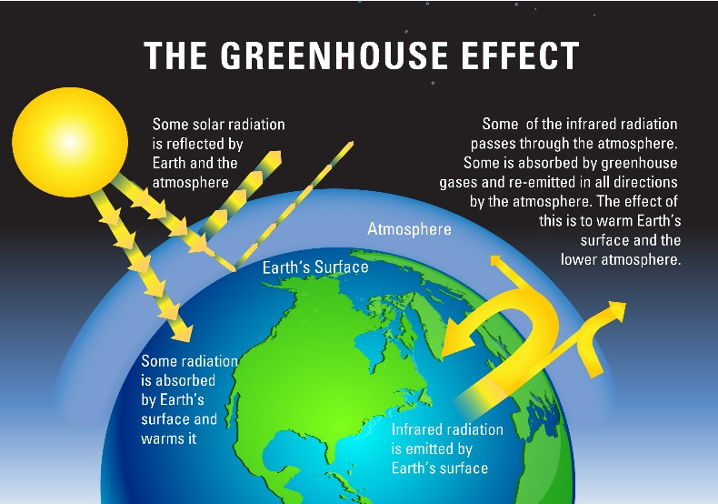

Long wave radiation emanating from Earth’s surface causes molecules of a specific size and structure to vibrate. The greenhouse gases of our atmosphere are of the right molecular size and structure for this to occur. This vibration allows the molecules of these gases to heat up. In the lab, we will be trapping carbon dioxide in a bottle by dropping Alka Seltzer tablets in water. Shining a bright, hot lamp on the bottles will cause the bottles to act just like the Earth’s atmosphere.

1. In Blackboard, there is an Excel spreadsheet labeled *A07-Greenhouse Gases*. Open this file so that you can record your measurements for this portion of the lab.
2. You are given two 16-ounce bottles. Using the water sink in the lab to rinse and carefully fill each about one-third with water.
3. Add *two broken Alka Seltzer tablets* to the bottled labeled ***CO2***.
4. Close up both bottles with the corks. There is no need to jam the cork all the way into the bottle. *You want to trap some of the CO2 in the bottle but not build up pressure.*

**Very important: The Alka Seltzer will be bubbling a lot once the Alka Seltzer are dropped into the water. Pull back the thermometer some for that cork, give the seltzer some time to stop most of its bubbling, and push the thermometer the rest of the way into the cork. The seltzer bubbles explode, leaving water droplets on the thermometer and keep the thermometer colder for longer.**

1. Push the thermometer for the CO2 bottle in until it’s about the same distance from the water as the *Air bottle*. The thermometer should be taking the *temperature of the air in the bottle and not sitting in the water*. Record the temperature of both thermometers as *t = 0* in the spreadsheet.
2. Position the bottles next to each other and aim the lamp evenly at both bottles (approximately 1-2 inches away). Turn on the lamp.
3. Record the temperature of both bottles every 1 minute for the next 15-20 minutes. (Be very careful to not mix up the temperatures in the table. One tip is to place the Alka Seltzer bottle on the left since its column is the left column in the table.)
4. As you record your data, the spreadsheet will continually make a graph of your data. At the end of 60 minutes, which bottle was warmer? Was it the bottle with regular air or the bottle with carbon dioxide?

|  |  |
| --- | --- |
| **Final Temperature: Carbon Dioxide** | **Final Temperature: Regular Air** |
|  |  |

1. Describe the general trend your temperatures took over time (did they continuously warm up, did they have a peak and then stop warming, etc...)? Include the graph of your data that was generated in Excel.

|  |
| --- |
| Enter Answer Here |

1. What was happening to the light inside the bottle with extra carbon dioxide, and how did this affect the temperature compared to a thermometer in plain air?

|  |
| --- |
| Enter Answer Here |

1. Describe the similarities between this experiment and concerns about global climate change?

|  |
| --- |
| Enter Answer Here |

1. How would Earth’s climate be different if there were no carbon dioxide in the atmosphere at all?

|  |
| --- |
| Enter Answer Here |

|  |
| --- |
| ***Part B: Atmospheric Distortion*** |

**This portion of the lab is performed by one group at a time. When one group finishes, the next group should move to observe the equipment setup.**

Look up at the night sky, and you’ll see that the stars seem to be twinkling. Earth’s atmosphere causes this effect by bending the light in random directions. When a telescope on the ground looks up at the night sky through the atmosphere, it gets a blurry image.

This problem is called atmospheric distortion. Astronomers avoid it as best they can by building ground-based observatories on mountaintops, where the atmosphere is thin. We will be simulating stars twinkling by shining a laser through the turbulent steam from boiling water.

**There will be a hot plate, boiling water, and steam in this portion of the lab. Please be mindful of what you touch. Be sure to use the oven mitts that are provided before touching anything.**

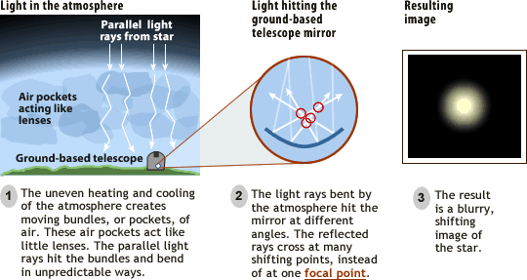

1. Visit the portion of the lab where there are two red lasers pointed at a blank piece of paper.
2. Carefully make sure that one of the lasers is pointed just above the two spouts from the top of the hot plate. The stand for the laser can be raised and lowered by adjusting the knob on the jack.

Describe what you see for each laser. Does one twinkle more than the other? Do they both twinkle? Are they both sitting still?

|  |
| --- |
| Enter Answer Here |

1. Carefully move the lasers so that the second laser pointer is aimed through the steam while the first is now not aimed through the steam.
2. Which laser is now twinkling?

|  |
| --- |
| Enter Answer Here |

1. Describe how this setup corresponds to our atmosphere and how stars twinkle because of it.

|  |
| --- |
| Enter Answer Here |

1. Explain, in detail, why most modern telescopes are built on mountain tops.

|  |
| --- |
| Enter Answer Here |

1. Look up and explain, in your own words, the technique *Adaptive Optics* that astronomers developed to correct for atmospheric distortion. For a video of what atmospheric distortion looks like magnified through a telescope watch this video:

<http://www.youtube.com/watch?v=R-YSH79PSJ4>)

|  |
| --- |
| Enter Answer Here |

|  |
| --- |
| ***Part C: Atmosphere Retention*** |

The thickness of a planet's atmosphere depends on the planet's gravity and the temperature of the atmosphere. A planet with weaker gravity does not have as strong a hold on the molecules that make up its atmosphere as a planet with stronger gravity. The gas molecules will be more likely to escape the planet's gravity. If the atmosphere is cool enough, then the gas molecules will not be moving fast enough to escape the planet's gravity. But how strong is ``strong enough'' and how cool is ``cool enough'' to hold onto an atmosphere? To answer that you need to consider a planet's escape velocity and how the molecule speeds depend on the temperature.

At the top of a planet's atmosphere, particles are running around in all directions, at all of the various speeds corresponding to the temperature. Some of the particles will be headed upwards, some downwards, and some sideways. Some of them will be moving slowly, some at an average speed, and some very quickly. Whether a planet will hold onto an atmosphere will depend upon the motions of those particles which happen to be moving the fastest. If those particles are moving upwards at less than the planet's escape velocity and will go up for a while, and then fall back into the atmosphere. However, if the particles were moving faster than the planet's escape velocity, they would follow paths which would take them out into space, never to return.

This portion of the lab will investigate the necessary conditions for a planet to retain an atmosphere.

We will return to the *NAAP Labs* simulation program we had used in previous experiments. If needed, you can again download the installation file for the program here

<https://astro.unl.edu/nativeapps/>

Open the *NAAP Labs* program, click on **Atmospheric Retention**, and then click on **Gas Retention Simulator**.

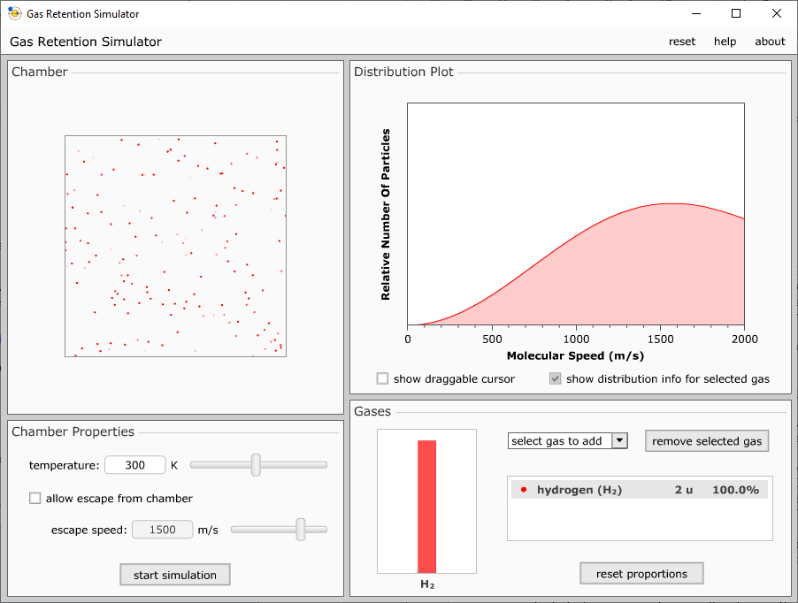

1. Set the *temperature* to 300K. (In units of **Kelvin**, that is approximately the temperature of the surface of the Earth). Next, use the drop down menu that says ‘select gas to add’ to add *Oxygen* to the simulation. Click *Start Simulation*.
2. Describe what’s going on with the particles in the box.

|  |
| --- |
| Enter Answer Here |

1. Stop the simulation and increase the temperature to 800K. Describe how this is different from the lower temperature simulation.

|  |
| --- |
| Enter Answer Here |

1. Add *Hydrogen* to the chamber, change the temperature back to 300K, and again watch the simulation. What do you notice about the red hydrogen atoms in this simulation?

|  |
| --- |
| Enter Answer Here |

1. Check the box for ‘allow escape from chamber’ and start the simulation. On the right, there are two bars: blue for oxygen and red for hydrogen. What quickly happens to the hydrogen in the simulation? Is much of the oxygen lost? Why is the hydrogen lost so much more easily?

|  |
| --- |
| Enter Answer Here |

1. Use the button to reset the proportions of atoms in the chamber, lower the temperature to 100K, and increase the escape speed. These settings are more similar to the Jovian planets of our solar system where they are massive (causing large escape velocities) and are cold.
2. When you run the simulation, what happens to the oxygen and hydrogen? Is the hydrogen lost faster or slower than before?

|  |
| --- |
| Enter Answer Here |

1. Reset the proportions of the elements, increase the temperature to 1000K, reduce the escape speed to about 700 m/s, and run the simulation. What happens to the elements? Which one is lost first? Is the oxygen lost faster or slower compared to when the simulation was run with the colder planet?

|  |
| --- |
| Enter Answer Here |

1. What planet in our solar system is this situation most like? For the planet you listed, does that planet have an atmosphere? If it does have an atmosphere, how thick or thin is its atmosphere? Does this simulation help confirm that fact?

|  |
| --- |
| Enter Answer Here |

1. Continue to work with the simulation by adding other gasses to the simulation, resetting the proportions, making it colder/hotter, and changing the escape velocity.
2. From this simulation, what type of planet can most easily retain its atmosphere? (Small, cold planets. Small, hot planets. Large, cold planets. Large, hot planets.) Why can this type of planet most easily retain an atmosphere?

|  |
| --- |
| Enter Answer Here |

*This lab manual was written by Justin Mason, Old Dominion University, and copied to be made available on this website by Corey Sargent, Old Dominion University, Fall 2021*