*Celestial Motion I Experiment A02*

|  |  |  |
| --- | --- | --- |
|  |  |  |
| Name |  | Lab Section |

*Objective*

* To review various astronomical topics: Celestial Motion, Constellations, Causes for the Seasons, and the Lunar Cycle

*Materials*

Computer with Internet Access

*Procedure*

During this lab we will use simulations that have been created at the University of Nebraska-Lincoln. These simulations will let us test a few astronomical concepts that are either difficult to replicate in the lab. The simulations let us test and adjust much more easily. These simulations use a combination of Java & Flash and are readily available for free.

Start by downloading the install files from Blackboard, or, if you are on your own computer, visiting the website

<https://astro.unl.edu/nativeapps/>

On this site, there are two categories of files: Windows and MacOS. You will need to download the *NAAP Labs* file and the *Classaction* file that is the appropriate file type for your computer.

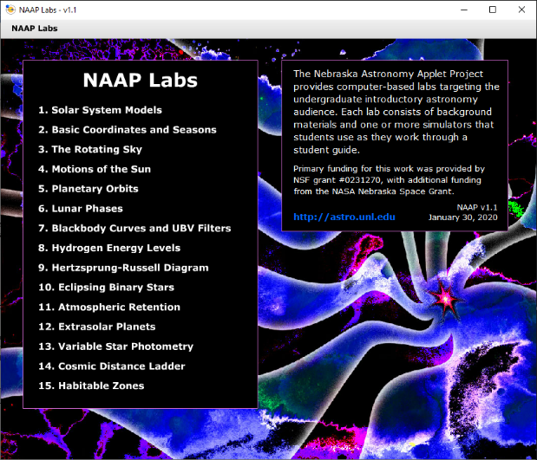

Once you have the files downloaded, go to the folder where they are saved on your computer. Double click one of them to install the simulations. Once the first program is installed, then install the other. The file sizes are small (~22 MB and ~97MB) and should install quickly. After the installations have finished, you will have a program on your computer titled *NAAP Labs* and one called *Classaction*.

In today’s experiment, we will only use the NAAP Labs. Open this program and a window like the one to the right will open.

|  |
| --- |
| ***Part A: Celestial Motion*** |

The first simulation we are using is located under *3. The Rotating Sky*. Click on this title and then click on ***Rotating Sky Explorer*** on the next page.

This simulation has two views: the left view shows the celestial sphere and how the Earth spins within it, the right view is your view from the ground and how you see the celestial sphere move (similar to what you saw on the dome earlier in the lab). Take a few minutes to familiarize yourself with how the simulation works and then answer the questions below.

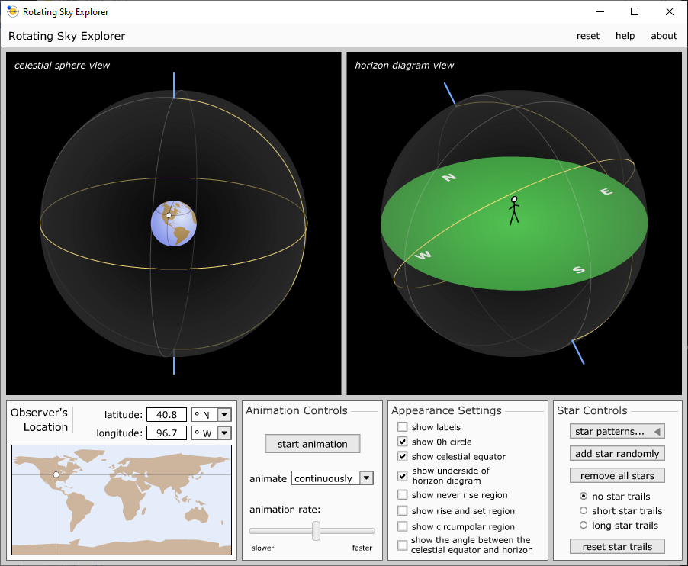

(Hint: Things to try with the simulation are to change your location on the Earth, drag around the globe, add stars to the celestial sphere, and add star trails. Make sure you click the *Start Animation* button to see the simulation run.)

1. Why do all objects on the celestial sphere rise in the east and set in the west?   
   (This answer requires much more detail than just, “Because the Earth rotates.”)

|  |
| --- |
| Enter Answer Here |

1. Set the location to Norfolk, (latitude = 36.9° N, longitude = 76.2° W). From this location:
   1. Are there stars that never rise?

|  |
| --- |
| Enter Answer Here |

* 1. Are there stars that never set?

|  |
| --- |
| Enter Answer Here |

* 1. Are there stars that are always up? What is the name for this type of star?

|  |
| --- |
| Enter Answer Here |

1. From Norfolk, what direction do you have to look to see circumpolar stars?

|  |
| --- |
| Enter Answer Here |

1. As you increase your latitude do you see more or less circumpolar stars? As you decrease your latitude do you see more or less circumpolar stars?

|  |
| --- |
| Enter Answer Here |

1. What do you think the motion of the stars would look like if you were at the North Pole? Where would Polaris (the North Star) be located?

|  |
| --- |
| Enter Answer Here |

1. What do you think the motion of the stars would look like if you were at the Equator? Where would Polaris be located?

|  |
| --- |
| Enter Answer Here |

|  |
| --- |
| ***Part B: Constellations*** |

*(For the following questions, just name 2 or 3 constellations that would be highest in the sky.)*

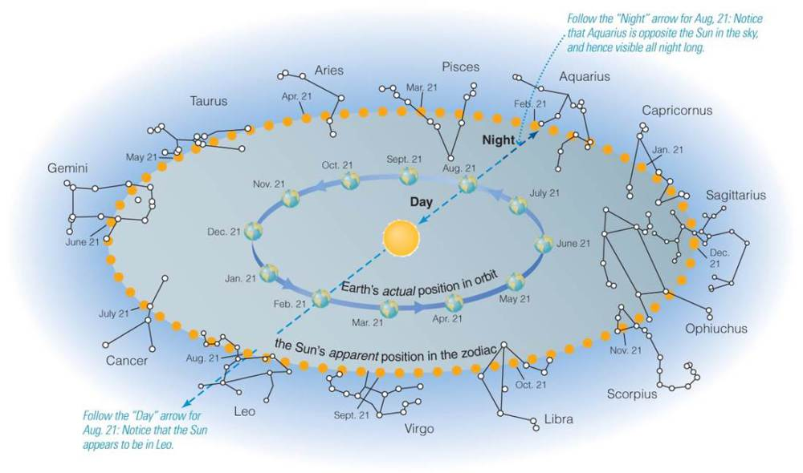

1. What constellations would be directly overhead at midnight in late January?

|  |
| --- |
| Enter Answer Here |

1. Find the Earth’s orbital position associated with your birth date (and indicate your birth date below). What Zodiac constellation does the Sun appear to be “in” on your birthday?

|  |
| --- |
| Enter Answer Here |

1. If the Sun didn’t shine so brightly, what Zodiac constellations would you see overhead around noon on your birthday?

|  |
| --- |
| Enter Answer Here |

1. What Zodiac constellations are overhead around midnight on your birthday?

|  |
| --- |
| Enter Answer Here |

1. What Zodiac constellations are overhead around midnight 6 months after your birthday?

|  |
| --- |
| Enter Answer Here |

1. Based on your above work, explain why the night sky changes seasonally. (This answer requires much more detail than just, “Because the Earth orbits the Sun.”)

|  |
| --- |
| Enter Answer Here |

|  |
| --- |
| ***Part C: Reasons for the Seasons*** |

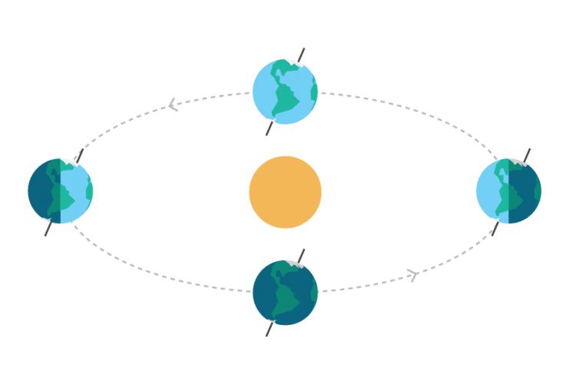

* 1. Draw arrows in the diagram to indicate the direction the Earth travels around the Sun.
  2. Label **Northern** spring, summer, fall, and winter.
  3. Label **Southern** spring, summer, fall, and winter.

|  |  |
| --- | --- |
| **Month** | **Earth-Sun Distance** |
| March | 149 million km |
| June | 152 million km |
| September | 150 million km |
| December | 147 million km |

* 1. The distance between the Earth and Sun during 4 months of the year are listed in the chart to the right. Based on this data, what can you conclude about the effect that the Earth-Sun distance has on the seasons? ***Support your conclusion by citing specific data.***

|  |
| --- |
| Enter Answer Here |

* 1. Describe, *in your own words,* what causes the seasons. Specifically, **why** does the tilt of the Earth’s axis result in some warmer months and some cooler months?

|  |
| --- |
| Enter Answer Here |

* 1. If, somehow, the Earth’s tilt changed from 23.5° to just 5°, what would change about the seasons?

|  |
| --- |
| Enter Answer Here |

|  |
| --- |
| ***Part D: The Lunar Cycle*** |

In the NAAP Labs program, click the *NAAP Labs* label in the top left to return to the main selection page. Our next simulation is located in *6 – Lunar Phases*. On the next page, choose ***Lunar Phase Simulator***.

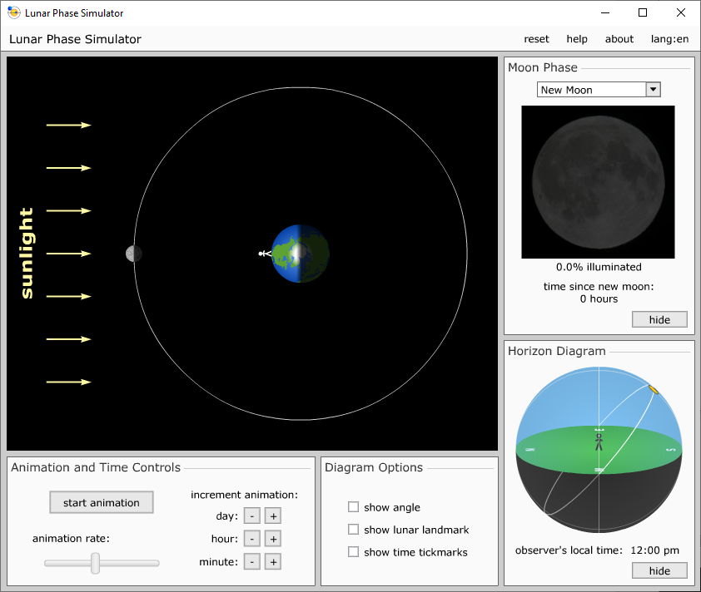

This simulation is a top-down view of the Earth looking at the North Pole. It can also show the position of the Moon in its orbit and the associated phase. Take a few minutes to familiarize yourself with how the simulation works, combine what you see in the simulation with the diagram below, and then answer the questions.

* 1. What Moon phase will an observer see if the Moon is directly overhead at sunset?

|  |
| --- |
| Enter Answer Here |

* 1. What Moon phase will an observer see if the Moon is directly overhead at sunrise?

|  |
| --- |
| Enter Answer Here |

* 1. What Moon phase can be seen for half of the night and then half of the day?

|  |
| --- |
| Enter Answer Here |

* 1. What Moon phase can be seen for half of the day and then half of the night?

|  |
| --- |
| Enter Answer Here |

* 1. The following sketches of the moon's appearance were made over about four weeks. Identify the phases and put them in the correct numerical order (full Moon is considered as 0, the starting point). One is labeled for you.

|  |  |  |  |  |  |  |  |  |  |
| --- | --- | --- | --- | --- | --- | --- | --- | --- | --- |
|  | **Picture** | **Order** | **Phase** | |  | **Picture** | **Order** | **Phase** | |
| A |  |  |  | | D |  |  | |  |
|  |  | |  | |  |
| B |  | 1 | Wanning Gibbous | | E |  |  | |  |
|  |  | |  | |  |
| C |  |  | |  | F |  |  | |  |
|  | |  |  | |  |

* 1. In the diagram below the sun's light is coming in from the right. The moon's location is marked at several points on its orbit. These are the points the moon was at when the sketches above were drawn. Identify each position with the letter of the corresponding sketch.

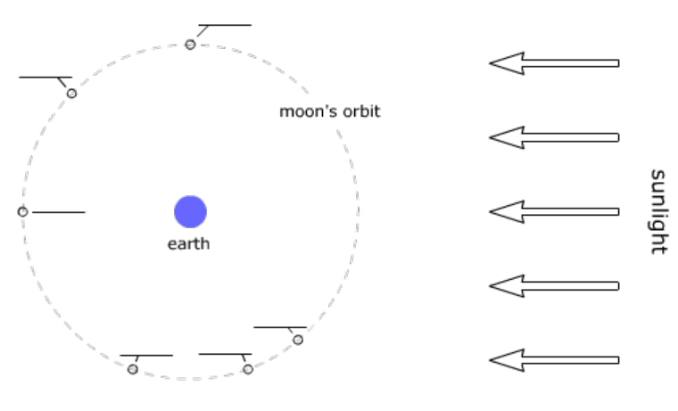

* 1. How long does it take the Moon to complete one cycle of phases, in days?

|  |
| --- |
| Enter Answer Here |

* 1. If the Moon is full today, what phase do you expect it to be at in a week?

|  |
| --- |
| Enter Answer Here |

* 1. How about one month later?

|  |
| --- |
| Enter Answer Here |

* 1. Is there a dark side of the Moon? (Note: this question can be effectively answered either yes or no, so it is important to thoroughly explain your reasoning.)

|  |
| --- |
| Enter Answer Here |

*This lab manual was written by Justin Mason, Old Dominion University, and copied to be made available on this website by Corey Sargent, Old Dominion University, Fall 2021*