*Interplanetary Travel Experiment A09*

|  |  |  |
| --- | --- | --- |
|  |  |  |
| Name |  | Lab Section |

*Objective*

* In this lab you will take part in an imaginary manned flight to Mars. In so doing, you will learn about orbits, periods, and velocities of natural planets and spacecraft.

*Materials*

Calculator

*Theory*

Putting the first human on Mars is one of the top priorities for space exploration for the next 1-2 decades. Currently, NASA plans to send people to Mars by the late 2030s. However, those plans may be rushed to win the next “space race” and get the first human there as early as 2033.

Getting to Mars is not easy. It’s not just the technological hurdles in our way. One of the primary concerns is the psychological effects of isolation for extended periods of time. What kinds of effects might arise from being away from Earth for so long? To investigate how long a trip to Mars may take, this lab walks you through some of the basic calculations on preparing for interplanetary travel.

*Procedure*

|  |
| --- |
| ***Part A: Planetary Orbits and Periods*** |

Below is a sketch of a planet’s orbit around the Sun. Kepler’s First Law tells us that it is an ellipse, with one focus at the Sun: *a*, the semimajor axis, is the average of the **perihelion** (closest to the Sun) and **aphelion** (farthest from the Sun) distances of the planet. The period of the planet (its year) is given by the formula

or

where the period *P* is given in years and *a* is given in astronomical units (AU).

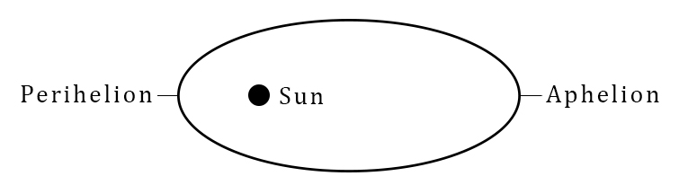

1. Given below is the semimajor axis and period of several planets. Use this to calculate the perihelion and aphelion distances using the following equations:

|  |  |  |  |  |  |
| --- | --- | --- | --- | --- | --- |
|  | ***a***  **(in AU)** | ***P***  ***(in years)*** | ***e*** | **Perihelion Distance (AU)** | **Aphelion Distance (AU)** |
| **Mercury** | 0.387 | 0.241 | 0.206 |  |  |
| **Venus** | 0.7233 | 0.615 | 0.007 |  |  |
| **Earth** | 1.000 | 1.000 | 0.017 |  |  |
| **Mars** | 1.527 | 1.881 | 0.093 |  |  |
| **Jupiter** | 5.203 | 11.862 | 0.048 |  |  |

|  |
| --- |
| ***Part B: Transfer Orbits*** |

The orbit of the manned spacecraft we will send to Mars will also be an ellipse, with the Earth’s orbit as perihelion and Mars’s orbit as aphelion. This configuration takes the least amount of energy (requires the least fuel and costs the least money).

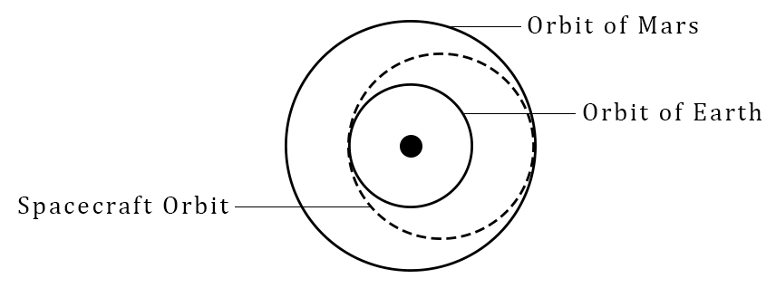

1. We will try to launch our spacecraft so that when we reach Mars it will be at perihelion. What would be the perihelion distance, aphelion distance, *a*, and *P* for our spacecraft? (Assume the Earth’s orbit is circular.)

|  |
| --- |
| Enter Answer Here |

1. Since we want to stop at Mars, the time it will take us to get there is just one-half our orbital period around the Sun. How long (in days) will it take us to get to Mars?

|  |
| --- |
| Enter Answer Here |

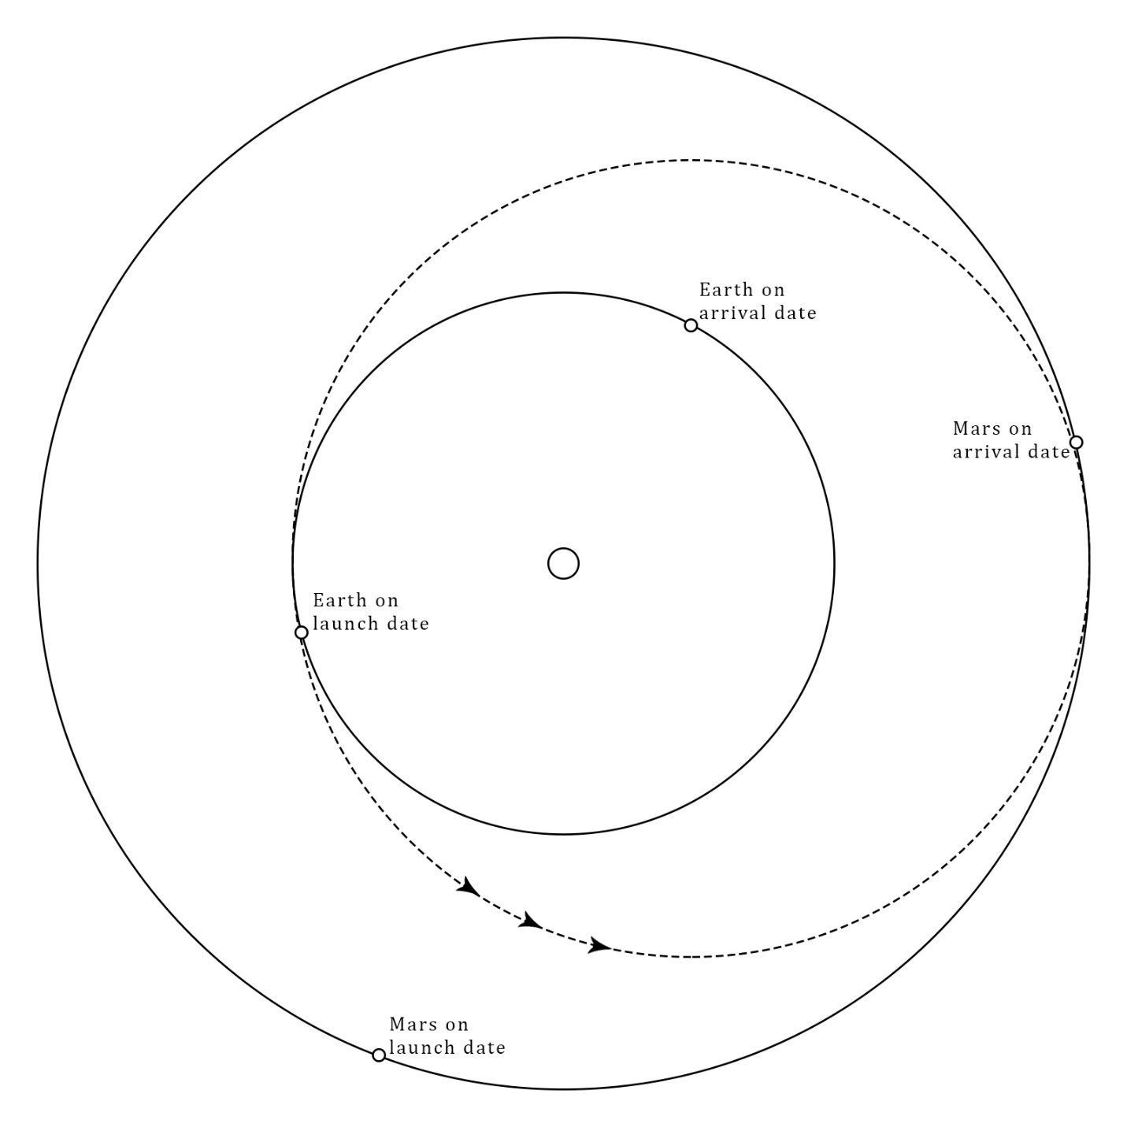

1. We decide to make our trip in 2029 AD. To reach Mars on March 3 (the approximate date it will reach perihelion that year), on what date would we have to leave Earth?

|  |
| --- |
| Enter Answer Here |

1. We find that we can’t reach Mars on March 3, 2029, because on our calculated launch date the Earth is not diametrically opposite the Sun from where Mars will be on March 3 (our condition for minimum energy, and thus, minimum fuel and cost). Instead, we launch on the first day of August 2028. Now when we reach Mars it will be 1.41 AU from the Sun. Because Mars will not be at perihelion when we arrive, how much longer will the trip take than we had calculated before? (*Hint*: Similar calculation but the spacecraft aphelion distance has changed.)

|  |
| --- |
| Enter Answer Here |

1. What will be the historic date of our landing to put the first people on Mars?

|  |
| --- |
| Enter Answer Here |

|  |
| --- |
| ***Part C: Velocities*** |

A planet’s speed in its orbit is given by the formula

where *V* is the velocity, *r* is the distance (at that instant) to the Sun in AU, and *a* is the semimajor axis of its orbit.

1. What is the Earth’s velocity in its orbit? (Assume a circular orbit.)

|  |
| --- |
| Enter Answer Here |

1. What is the velocity of Mars when it is at 1.41 AU from the Sun?

|  |
| --- |
| Enter Answer Here |

1. By calculating what our manned spacecraft’s velocity should be at 1 AU, we see how fast it must be going to be in the right orbit to reach Mars. By subtracting the Earth’s velocity from this number, we see how fast the spacecraft will have to be moving relative to the Earth. How fast will the spacecraft have to be traveling (relative to the Earth) immediately after escaping the Earth’s gravity in order to reach Mars as we planned?

|  |
| --- |
| Enter Answer Here |

1. How fast will the spacecraft be moving relative to Mars when we arrive there at 1.41 AU?

|  |
| --- |
| Enter Answer Here |

|  |
| --- |
| ***Part D: Communicating with Earth*** |

1. While we are on Mars, we will want to radio Earth now and then. At our farthest point from Earth, Mars will be about 2.66 AU from Earth. Knowing that 1 AU = 1.49 x108 km and that our radio signals travel with the speed of light, 2.99 x105 km/sec, how long will it take (in minutes) for our radio messages to reach Earth at its farthest point?

|  |
| --- |
| Enter Answer Here |

1. If we were trying to carry on a conversation with Earth, how long would we have to wait to hear the answer to an easy question we asked someone on Earth? (Consider the time for the message to travel there and the reply to come back.)

|  |
| --- |
| Enter Answer Here |

1. When Earth and Mars are at their closest approach, they are separated by 0.36 AU. How long would it take for a transmission to get from Mars to the Earth in this situation?

|  |
| --- |
| Enter Answer Here |

|  |
| --- |
| ***Part E: Return Trip*** |

We can’t just return from Mars anytime we’d like to. We’ll have to wait to take off (in order to conserve fuel and time spent traveling through space) until the Earth will be in the proper position at the end of our transfer orbit home. In general, we will have a long wait, but we’ll carry enough provisions to make it through (and we can explore Mars in the meantime).

1. An accurate calculation of the time we will have to wait is complicated, but we can put an upper limit on it by realizing that after one synodic period the Earth will be in the same place, relative to Mars, as it was when we landed. Surely the two plants will go through the proper configuration for launch before then. Using the formula

calculate what the synodic period would be (and thus the longest wait time). (*Psyn* is the synodic period.)

|  |
| --- |
| Enter Answer Here |

1. We have finally arrived home with samples, photos, and so on. Assuming we had to wait only 3/4 of the synodic period before leaving Mars, how long was the entire trip to Mars and back?

|  |
| --- |
| Enter Answer Here |

*This lab manual was written by Justin Mason, Old Dominion University, and copied to be made available on this website by Corey Sargent, Old Dominion University, Fall 2021*