*Gravity and Energy Experiment A04*

|  |  |  |
| --- | --- | --- |
|  |  |  |
| Name |  | Lab Section |

*Objective*

* Part A: Acceleration Due to Gravity
* Part B: Conservation of Energy
* Part C: Other Forms of Energy

*Materials*

Free Fall Adapter Free Fall Balls (2) (1 large, 1 small)

Right Angle Clamp Universal Table Clamp

Photogate Timer w/memory Photogate Timer Power Supply (9V)

Two-meter Stick Lab Support Rod, 36"

Graph Paper Ruler

*Procedure*

|  |
| --- |
| ***Part A: Acceleration Due to Gravity*** |

You will study the motion of an object that is under the influence of gravity. To simplify your observations in this experiment you will neglect air resistance, and furthermore, no extra force will be applied to the object to make it fall. Thus, the object will be in ‘free fall’ and *the acceleration of the falling object should be equal to the acceleration due to gravity.*

In this experiment, two different mass balls will be dropped, falling freely downward under the influence of gravity. The distance that the ball falls as a function of time will be investigated. In general, for an object moving with constant acceleration *a*, the distance *d* it travels in time *t* is given by:

**(1)**

if the object starts at rest.

You will measure the time it takes for the ball to fall various distances and determine the acceleration of the ball from your data. Rearranging Equation (1) and solving for acceleration *a* we find that the acceleration is given by:

**(2)**

The Pasco Free Fall Adapter and a Photogate timer will be used to determine the distance a ball falls in a certain amount of time. First, the ball will be timed for fixed distance intervals. This will be done for projectiles of two different masses (large, more massive, and small, less massive balls).

* **Equipment Setup**

1. Connect the Free Fall Adapter to the Photogate Timer
2. Connect the power supply to the Photogate Timer and electrical outlet.
3. Attach the Universal Table Clamp to the edge of the lab table and lock it in place with the thumbscrew.
4. Insert the 36” lab support rod in the Universal Table Clamp and lock it in place with the thumbscrew.
5. Attach the right angle clamp to the top of the lab support rod and lock it in place with the thumbscrew.
6. Slide the free fall adapter rod into the right angle clamp and lock it in place by tightening the thumbscrew on the right angle clamp. Your equipment setup should be similar as to that shown in the figure below.

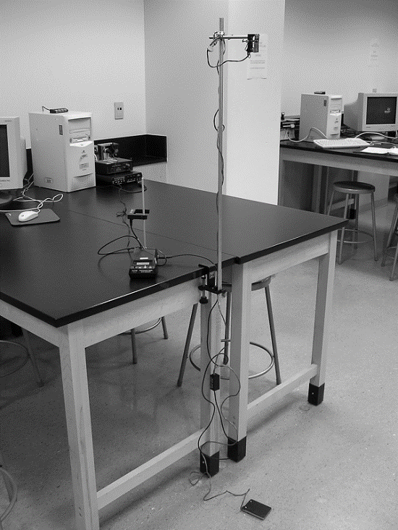

1. Adjust the Free Fall Adapter so that the release mechanism is at maximum height. Measure and record the height in Data Table 1.

1. Place the timer pad on the floor directly below the release mechanism. The Photogate Timer should be in *gate mode* so that it records the elapsed time after the ball is released until it hits the sensor pad on the floor. Try releasing the ball several times and make sure that the times are sensible.

*Note:* The Free-Fall Adapter operates by passing a small, harmless electric current through the release mechanism. The metal ball forms part of the initial circuit which “freezes” the timer. When the ball is dropped, the circuit is broken and the timer starts. The timer will continue to run until the ball strikes the sensor pad on the floor which causes the timer to stop.

###### Data Collection

1. When everything is set up, release the larger ball from the maximum height and record the elapsed time in Data Table 1. Repeat this for a total of 5 attempts, and record the fall time in the data table below.
2. Release the smaller ball from the maximum height and record that time in Data Table 2. Repeat this for a total of 5 attempts, and record the fall time in the data table below.
3. Use Equation (2) to calculate the acceleration due to gravity for each the large and small ball. Record the values in Data Tables 1 and 2.
4. For each ball, find the *percent difference* between the value of your calculated acceleration and the accepted value of acceleration (9.81 m/s2).

**Data Table 1: Large Ball – More Massive**

|  |  |  |  |
| --- | --- | --- | --- |
| **Height to the Ball** | | | m |
| **Trial #** | **Time** *t* (s) | (s2) | Acceleration (m/s2) |
| 1 |  |  |  |
| 2 |  |  |  |
| 3 |  |  |  |
| 4 |  |  |  |
| 5 |  |  |  |
| **Average Acceleration** | | | m/s2 |
| **Accepted Value of Acceleration Due to Gravity** | | | 9.81 m/s2 |
| **% difference** | | | % |

**Data Table 2: Small Ball – Less Massive**

|  |  |  |  |
| --- | --- | --- | --- |
| **Height to the Ball** | | | m |
| **Trial #** | **Time** *t* (s) | (s2) | Acceleration (m/s2) |
| 1 |  |  |  |
| 2 |  |  |  |
| 3 |  |  |  |
| 4 |  |  |  |
| 5 |  |  |  |
| **Average Acceleration** | | | m/s2 |
| **Accepted Value of Acceleration Due to Gravity** | | | 9.81 m/s2 |
| **% difference** | | | % |

1. Did both the large and small masses take approximately the same time to drop? Did they accelerate at approximately the same rate?

|  |
| --- |
| Enter Answer Here |

1. Given Newton’s Laws, we have the equation

where *g* is you calculated value for the acceleration due to gravity, *G* is Newton’s Gravitational Constant (6.67 x10-11 m3kg-1s-2), and *R* is the radius of the Earth (6.378 x106 m). Using this equation, calculate the mass of the Earth. Look up the mass of the Earth online. Is your calculation close? Show all your work below.

|  |
| --- |
| Enter Answer Here |

1. If you performed this same experiment on the Moon, would you get the same acceleration due to gravity? Why or why not?

|  |
| --- |
| Enter Answer Here |

|  |
| --- |
| ***Part B: Conservation of Energy*** |

The law of conservation of energy is a law of science that states:

*“Energy cannot be created or destroyed, but only changed from*

*one form into another or transferred from one object to another.”*

A common example of this law is that of a falling object. An object held high off the ground has a lot of gravitational potential energy because it has the “potential” to fall. If you let go of the object it will fall towards the ground. As the object falls it will pick up speed due to gravity. It’s gravitational potential energy is not lost. Instead, it is being transformed into kinetic energy (the energy of an object in motion). When the object hits the ground, the energy is again not lost. The kinetic energy is transformed into other types of energy which generate sound, heat, or even create a small crater where the object landed.

In astronomy, one way to consider how an object orbits is to look at a planet’s energy at various points.

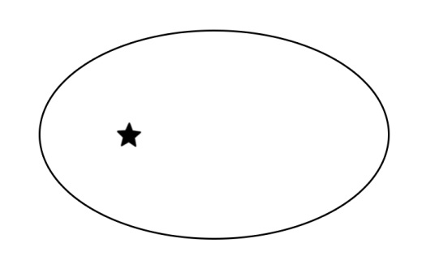

Consider the orbit above:

* 1. Draw and label the position along the planet’s orbit where the planet is moving the *fastest*.
  2. Draw and label the position along the planet’s orbit where the planet is moving the *slowest.*
  3. Draw and label the position along the planet’s orbit where the planet has the *most kinetic energy*.
  4. Draw and label the position along the planet’s orbit where the planet has the *least kinetic energy*.
  5. Draw and label the position along the planet’s orbit where the planet has the *most gravitational potential energy.*
  6. Draw and label the position along the planet’s orbit where the planet has the *least gravitational potential energy.*
  7. Describe how the *total* *energy* of the planet’s orbit changes with time.

|  |
| --- |
| Enter Answer Here |

|  |
| --- |
| ***Part C: Other Forms of Energy*** |

Thermal energy is the energy a substance or system has related to its temperature, i.e., the energy of moving or vibrating molecules.  Atoms and molecules, the smallest particles of any substance, are always in motion.  The motion of thermal energy is usually not visible, but we can feel or see its effects.  We use thermal energy to cook our food and heat our homes, and we use it to generate electricity.

1. Consider *temperature* and *thermal energy*.
   1. What is the difference between temperature and thermal energy?

|  |
| --- |
| Enter Answer Here |

* 1. If you stick your hand into a 400° oven, you don’t get burned. However, if you stick your hand into a boiling pot of water at 212° you’ll get a severe burn! If the oven temperature is much hotter than the water temperature, why don’t you get burned by the oven?

|  |
| --- |
| Enter Answer Here |

Mass-energy equivalence states that mass is concentrated energy. In his theory of special relativity, Einstein formulated the equation E=mc2. There is a tremendous amount of energy stored within in matter!

A 20g marble contains as much energy as a 500-kiloton hydrogen bomb, but this energy is very difficult to release. It can be released through matter-antimatter annihilation, when matter and antimatter come together. Nuclear reactions can be understood to release so much more energy than chemical reactions because of the matter conversion.

1. How much mass-energy is there in 1 gram of matter (about as much mass as a paper clip)? Assuming you could convert this entire mass into energy, for how many years could you run a 100W light bulb off the energy contained within this gram of matter?

**Hint:**

1 gram = 1g = 0.001 kg

Speed of light = c = 2.99 x108 m/s

Recall that 1 W = 1 J/s, so a 100 W light bulb consumes 100 J of energy every second.

|  |
| --- |
| Enter Answer Here |

*This lab manual was written by Justin Mason, Old Dominion University, and copied to be made available on this website by Corey Sargent, Old Dominion University, Fall 2021*